|  |
| --- |
| IALA Guideline |

1234

Measurement of Marine Lights Performance

Edition 1.0

Document date

Revisions to this IALA Document are to be noted in the table prior to the issue of a revised document.

|  |  |  |
| --- | --- | --- |
| Date | Page / Section Revised | Requirement for Revision |
|  |  |  |
|  |  |  |
|  |  |  |
|  |  |  |
|  |  |  |
|  |  |  |
|  |  |  |

1. INTRODUCTION 12

2. SCOPE 12

3. OBJECTIVE 13

4. terms and definitions 13

4.1. Photometry 13

4.2. Spectral luminous efficiency <for a specified photometric condition> 13

4.3. Spectral distribution 15

4.4. Spectral Power Distribution 16

4.5. Luminous Flux (lumen) 16

4.6. Solid Angle <of an area subtended at a point>(steradian) 17

4.7. Luminous Intensity (candela) 18

4.7.1. Angular luminous intensity distribution 19

4.7.2. Time dependent luminous intensity distribution 19

4.7.3. Fixed Intensity 19

Continuous Intensity 19

4.7.4. Maximum Intensity 19

4.7.5. Reference Intensity 19

4.7.6. Peak Intensity 19

4.7.7. 10th Percentile Intensity 19

4.7.8. Time-Integrated Intensity 19

4.7.9. Effective Intensity 20

4.8. Luminance 20

4.9. Illuminance 21

4.10. Beam Divergence 22

4.11. Critical Flicker Frequency OR Fusion Frequency 22

4.12. Crossover Distance 22

4.13. Measurement Distance 23

4.14. Measurement Angle 23

4.15. Limiting Photometric Distance 23

4.16. Root-mean-square value 23

4.17. Goniometer 23

4.18. GonioPhotometer 23

4.19. Goniospectroradiometer 24

4.20. Colorimetry 24

4.21. CIE standard colorimetric observer 24

4.22. Tristimulus values, <of a colour stimulus> 24

4.23. Chromaticity coordinates 25

4.24. Chromaticity 25

4.25. Color temperature 26

4.26. Correlated Colour Temperature 27

4.27. Response time 27

4.28. Photometric centre 27

4.29. Reference center<of the DUT> 27

5. MEASUREMENT PRINCIPLES 27

5.1. Photometric Distance Law 27

5.2. Coordinate systems 28

5.3. Photometric measurement 30

5.3.1. Spectrophotometry Measurement (based on spectrum) 30

5.3.2. Integral Method Measurement 31

5.4. Colorimetric measurement 32

5.4.1. Spectral measurement 32

5.4.2. Integral method measurement 32

5.5. Principle of spectral measurement 33

5.5.1. Mechanical scanning spectroradiometer 33

5.5.2. Array-based Spectroradiometer 34

5.6. Measurement of modulated light 34

5.6.1. Talbot-Plateau Law 34

5.6.2. Photometric measurements 34

5.6.3. Spectroradiometer measurements 34

5.7. Effective intensity of rhythm light 34

5.8. Absolute photometry and relative photometry 34

6. MEASUREMENT EQUIPMENT 35

6.1. Equipment configuration/general rules 35

6.2. Photometer 35

6.3. Goniometer 35

6.4. ‘Folding’ Mirror 36

6.5. Tristimulus Colorimeter 36

6.6. Spectroradiometer 36

6.7. Calibration Light Sources 36

7. GENERAL Measurement Conditions 37

7.1. Test classification 37

7.2. Requirement for Items Under Test 37

7.3. Environmental Conditions 37

7.4. Power/Electrical Conditions 38

7.5. Equipment Warm-up 39

7.6. Stray and Ambient Light Control 39

8. PHOTOMETRY METHODS AND REQUIREMENTS 40

8.1. Standard Laboratory Photometry 40

8.2. luminous flux Measurement of light sources 40

8.3. Alignment 40

8.4. Spectral Correction 41

8.5. Reference center 42

8.6. Limiting Photometric Distance 43

8.7. Measurement Aperture and Measurement Angle 45

8.8. Measurement of Luminous Intensity and its Angular distribution 46

8.8.1. General 46

8.8.2. Recommended Measuring Planes 46

8.8.3. Luminous intensity distribution measurement 48

8.8.4. Measurement of Specification Peak Intensity 50

8.8.5. Measurement of Specification Peak Intensity of array AtoN light 51

8.9. Measurement of rhythm of Light and flash duration 51

8.10. Detailed Measurement Methods 52

9. COLORIMETRY METHODS AND REQUIREMENTS 52

9.1. Standard Laboratory Colorimetry 52

9.2. Alignment 53

9.3. Measurement System Spectral Response 53

9.3.1. Tristimulus colorimeter 53

9.3.2. Spectroradiometer 53

9.4. Illumination of the Measurement Aperture 54

9.5. Considerations of Rapid Intensity Fluctuation of the Light Source 54

9.6. Minimum Measurement Distance 54

9.7. Measurement Procedure 54

9.7.1. Tristimulus colorimeter 54

9.7.2. Spectroradiometer 54

9.8. Detailed Measurement Methods 55

10. PRESENTATION OF RESULTS 55

10.1. Luminous Intensity versus Angle 55

10.1.1. Main Values of Symmetric/Asymmetric Intensity Distribution 55

10.1.2. Main values for Omnidirectional Beacons (fan beams) 57

10.1.3. Rotating Beacons (pencil beams) 57

10.1.4. Directional Beacons 58

10.2. Luminous Intensity versus Time 58

10.3. Flash Duration 58

10.4. Effective Intensity 58

10.5. Spectral Correction 59

10.6. Service Conditions Allowance 59

10.7. Light Colour 59

10.8. Sector Lights 60

10.9. Spectral Power Distribution 62

10.10. Nominal Range 62

10.11. Uncertainty & Confidence 63

11. MEASURING IN FIELD APPLICATIONS 63

11.1. General 63

11.2. Key problems 63

11.2.1. Remote Collection of AtoN Light 63

11.2.2. Stable Acquisition of AtoN Light 63

11.2.3. Elimination of the interference of Background Light 63

11.2.4. Irregular Rhythm of Light 64

11.3. Irregular Rhythm of Light 64

12. ACRONYMS 64

13. REFERENCES 65

*ANNEX A* DETAILED MEASUREMENT METHOD - ZERO-LENGTH PHOTOMETRY 67

A 1. INTRODUCTION 67

A 2. OFF-AXIS ZERO-LENGTH PHOTOMETRY 68

A 3. CALIBRATING OR CHARACTERISING THE ZERO-LENGTH SYSTEM 68

*ANNEX B* DETAILED MEASUREMENT METHOD - OUTDOOR TELEPHOTOMETRY 70

B 1. INTRODUCTION 70

B 2. ADDITIONAL EQUIPMENT REQUIRED FOR OUTDOOR TELEPHOTOMETRY 70

B 2.1. Telephotometer 70

B 2.2. Reference Light 70

B 3. CALIBRATION PROCEDURES 71

B 4. ATMOSPHERIC CONDITIONS AND AMBIENT LIGHT 71

B 5. RECORDING ENVIRONMENTAL CONDITIONS 71

B 6. ALIGNING THE TELEPHOTOMETER 71

B 7. MEASUREMENT PROCEDURES FOR OUTDOOR TELEPHOTOMETRY 72

B 8. ADDITIONAL EQUIPMENT FOR ‘IN SITU’ MEASUREMENT 72

B 8.1. Prisms and Prism Frame 72

B 8.2. Reference Projector 72

B 9. ADDITIONAL PROCEDURES FOR ‘IN SITU’ MEASUREMENT 74

B 9.1. Choice of Measurement Site 74

B 9.2. Setting Up the Telephotometer 74

B 9.3. Setting Up the Lighthouse Optic 74

B 9.4. Setting Up the Prism Frame and Prisms 74

B 9.5. Setting Up the Reference Projector 74

B 9.6. Carrying Out the Measurement 75

*ANNEX C* DETAILED MEASUREMENT METHOD - TRISTIMULUS COLORIMETRY 76

C 1 MEASUREMENT GEOMETRY 76

C 2 APPLICATION 1 76

C 3 APPLICATION 2 77

C 4 SPECTRUM 77

*ANNEX D* DETAILED MEASUREMENT METHOD - SPECTRORADIOMETRY 79

D 1 MEASUREMENT GEOMETRY 79

D 2 CALIBRATION / CHARACTERISATION 79

D 3 CARRYING OUT THE MEASUREMENT 80

D 4 RESULTS 80

D 5 CONVERTING SPECTRAL DATA TO COLOUR AND CHROMATICITY 80

*ANNEX E Laboratory measurement management* 81

*ANNEX F* Analysis and reference of error factors in goniophotometry 83

*ANNEX G* Implementation of the Convolution Function to Determine Flash Duration 91

*ANNEX H* EXAMPLE OF A PHOTOMETRY UNCERTAINTY BUDGET 92

*ANNEX I* Method for Detecting Character of AtoN Light Based on Spectral Analysis 98

*ANNEX J* Detection Method of AtoN Light Based on Image Processing Techniques 102

*ANNEX K* Practical Methods of Measuring Light Source Degradation 103

List of Tables

Table 1 Older units of luminance 20

Table 2 Older units of illuminance 21

Table 3 Example of a Spectroradiometer Correction File 81

List of Figures

*Figure 1* Photopic Luminous Efficiency Function V(λ) 14

*Figure 2* Scotopic Luminous Efficiency Function V’(λ) 15

*Figure 3* Spectral Power Distribution of White LED (5nm intervals) 16

*Figure 4* Calculation diagram of Solid Angle 17

*Figure 5* Diagram of the corresponding Solid Angle of 1 sr 18

*Figure 6* Diagram of illuminance 21

*Figure 7* Beam Divergence 22

*Figure 8* The CIE 1931 Standard Colour Observer 24

*Figure 9* The CIE 1931 Chromaticity Diagram 26

*Figure 10* CIE x, y Chromaticity Diagram Showing Color Temperature 26

*Figure 11* Photometric Distance Law 28

*Figure 12* Three Types of Coordinate Systems 30

*Figure 13 Typical Goniophotometer of the A-*α *Coordinate System* 31

*Figure 14 Diagram of Integral Method in Photometric Measurement* 32

*Figure 15* Spectral Plot showing Differences between Typical Photometer Response and V(λ) 32

*Figure 16* Expanded Section of Spectrum Highlighting Photometric Error in Figure 15 33

*Figure 17* Schematic of a simple Tristimulus Colorimeter 34

*Figure 18* Schematic of Czerny-Turner Stepping Monochromator 35

*Figure 19 Schematic diagram of array spectroradiometer* 35

*Figure 20* Folding Mirror Schematic 37

*Figure 21 Schematic diagram of LED light color performance changing with temperature* 40

*Figure 22* Stray light reduction by absorbing screens 41

*Figure 23* Arrangement to determine ambient and stray light 41

*Figure 24 Installation diagram* 42

*Figure 25* Crossover Distance 45

*Figure 26* Measurement Angle 46

*Figure 27* Horizontal Plane 48

*Figure 28* Vertical Plane 48

*Figure 29* Horizontal Plane of a Fan Beam 48

*Figure 30* Vertical Plane of a Fan Beam 49

*Figure 31 Horizontally Rotational Scanning* 50

*Figure 32 Vertically Rotational Scanning* 50

*Figure 33* Symmetrical Intensity Distribution 57

*Figure 34* Asymmetrical Intensity Distribution 57

*Figure 35* Scatter plot of red LED beacon over 360° 60

*Figure 36* Plot of chromaticity across the boundary between red and white sectors 61

*Figure 37* As Figure 36 but plotted on a partial CIE 1931 Chromaticity Diagram 62

*Figure 38* Method of Plotting Sector of Uncertainty on Intensity Graph 62

*Figure 39* 360 degree Plot of Sector Light showing Intensity and Chromaticity at 1° Intervals 63

*Figure 40* Partial Plot of Sector Light shown in Figure 34 Plotted at 0.1° Intervals 63

*Figure 41* Zero-Length Photometry System 68

*Figure 42* Zero-Length Geometry showing Angular Resolution 68

*Figure 43* Off-Axis Zero-Length Geometry 69

*Figure 44* The use of Prisms to Divert a Beam through a Vertical Angle 74

*Figure 45* Standard arrangement 77

*Figure 46* Simple Test for Setting Up Colorimeter 77

*Figure 47* Beacon outside sphere 78

*Figure 48* Beacon inside sphere 78

*Figure 49* Spectroradiometer Measurement Geometry 80

*Figure 50* Unknown luminaire on a goniophotometer 84

*Figure 51* Evasion of a non-centered light emission reference on a goniometer 85

*Figure 52* Reference plane 86

*Figure 53* Converging lens 87

*Figure 54* Setup of converging lens on goniometer 87

*Figure 55* Pencil beam fresnel lens 88

*Figure 56* Pencil beam light 88

*Figure 57* Plan view at a 'radial drum LED layout' luminaire 89

*Figure 58* Classical drum lens with filters, plan view 89

*Figure 59* Projector set on the goniometer, plan view 90

*Figure 60* Measuring an arrangement of projectors 90

*Figure 61* Shifting the active projector to the centre of rotation 91

*Figure 62* Typical application of the MAM. The flash (blue) is convolved with the visual impulse response function (green) to produce the perceived flash (orange). 92

*Figure 63* Diagram of detecting system 100

List of Equations

*Equation 1* Conversion relationship between photometric quantity and spectral radiometric quantity 14

*Equation 2* Spectral distribution 15

*Equation 3* Luminous flux 16

*Equation 4* Derivation of Luminous flux from spectral radiant flux distribution 16

*Equation 5* Determination of Luminous flux based on luminous intensity distribution 16

*Equation 6* Determination of solid angle 16

*Equation 7* Luminous intensity 17

*Equation 8* Derivation of luminous intensity from spectral radiant intensity distribution 17

*Equation 9* Time-integrated intensity 18

*Equation 10* Luminance 19

*Equation 11* Illuminance 20

*Equation 12* Derivation of illuminance from spectral irradiance 20

*Equation 13* Root mean square for a time interval 22

*Equation 14* Root mean square for equally spaced time intervals 22

*Equation 15* Tristimulus values *X*, *Y*, *Z* 24

*Equation 16* Chromaticity coordinate x 24

*Equation 17* Chromaticity coordinate y 24

*Equation 18* Photometric Distance Law 26

*Equation 19* Photometric Inverse Square Law 27

*Equation 20* Spectral correction factor 40

*Equation 21* Correction factor 41

*Equation 22* Crossover distance 42

*Equation 23* Crossover distance – approximation (1) 43

*Equation 24* Crossover distance – approximation (2) 43

*Equation 25* Crossover distance – approximation (3) 43

*Equation 26* Crossover distance – Precision sector projector 43

*Equation 27* Measurement angle (a<<d) (1) 44

*Equation 28* Measurement angle (a<<d) (2) 44

*Equation 29 Effective luminous intensity of the reference rhythm light* 50

*Equation 30 Normalized Spectral Responsivity of Colorimeter* 52

*Equation 31 Spectral Mismatch Correction Factor of Colorimeter* 52

*Equation 32 Relative spectral power distribution* 53

*Equation 33* Approximation of angular resolution 67

*Equation 34* ‘Corrected’ length of the light path 67

*Equation 35* Spectral response 77

*Equation 36* Relative error of luminous intensity 82

*Equation 37 Distance relation in goniometer* 83

*Equation 38 Angle relationship in goniometer* 83

*Equation 39 Angle error in goniometer* 84

*Equation 40* Estimation *of angular error* ∆X *in goniometer* 84

*Equation 41 Estimation of angular error* ∆ Y *in goniometer* 84

# INTRODUCTION

This document is one of several parts dealing with aid-to-navigation signal lights and concerns their measurement, both photometric and colorimetric. Before bringing into service a new type of aid-to-navigation light, at least one equipment of each type shall be subjected to appropriate photometric and colorimetric measurements. These measurements shall provide information on the luminous intensity and colour of the light for substantially all directions within its zone of utilization. Measurements on flashing lights shall provide information on the variations of luminous intensity with time. The collated information from all measurements shall be used to assign the following for the equipment when deployed as an AtoN signal light:

* rhythmic character (as described in E-110);
* colour (as described in E-200-1);
* nominal range (as described in E-200-2).
* effective intensity (as described in E-200-4).

Manufacturers of marine signal lights may use the results of such measurements to provide a specification of product performance. Measurements may be carried out on equipment already in service to ensure continued quality of performance, both to the AtoN provider and the mariner.

In each country, the competent technical authority shall determine the appropriate measurements to be made for each type of aid-to-navigation light. Photometric and colorimetric methods shall be determined by the laboratory to which the task is assigned but, as an indication of the general principles to be followed, reference should be made to this document.

The measurement of light is a complex subject and there is a danger that uninformed practitioners could achieve measurement results containing large errors of which they are unaware. Even when such errors are corrected or accounted for, the measurement result may still have a measurement uncertainty of several percent and in some cases tens of percent. Sometimes, such high uncertainties are unavoidable.

However, whatever measurement method is used, and whatever errors and uncertainties attained, it is important to properly evaluate them. The best way of doing this is using an uncertainty budget. Properly used, this budget can be used, not only to determine uncertainty, but also to refine the measurement method by addressing dominant uncertainties. It should be remembered that no measurement result is complete without a statement of uncertainty and confidence.

# SCOPE

This guideline applies to the measurement and characterisation of all marine aids-to-navigation signal lights. In general, the emissions provided by these signal lights may be categorized as ‘pencil beams’ or ‘fan’ beams.

Equipment used to generate pencil beams include searchlight-style or projector beacons, with single or multiple optics, and assemblies of ‘bulls-eye’ lenses rotating about a common focal point. The peak fixed intensities provided by these beacons range from a few thousand to several million candelas, with beam spreads (as measured between the 50% intensity points) typically less than ten degrees in any cross section. Searchlight-style beacons may be fixed in position, to provide a *leading light* for marking a navigational channel, or may be rotated about a vertical axis to sweep the horizon and provide the appearance of a flashed light when viewed from a distance.

Anamorphic cylindrical lenses are typically used to generate fan beams. These lenses are usually made from Fresnel sections and can be drum or ‘beehive’ in shape. Such optics may be used to produce a uniform light signal about the horizontal plane (an omnidirectional signal). The signal may be blanked or coloured in one or more sections around the horizon, or may exhibit one or more areas of increased intensity using condensing panels. The peak fixed intensities provided by these beacons range from a few tens of candelas to tens of thousands of candelas.

The types of light sources used in marine aids-to-navigation signal lights are diverse. Light emitting diodes (LEDs) are gradually replacing tungsten filament lamps or metal halide lamps., while acetylene open flame or gas-mantle light sources has almost ceased to exist.

# OBJECTIVE

The objective of this guideline is to provide an approved methodology to promote uniformity in determining and reporting the optical performance of a diverse group of marine aids-to-navigation signal lights. The optical performance covered in this guideline include the luminous intensity, color, character (of a navigation light), effective luminous intensity, and luminous range of the marine AtoN signal lights.

# terms and definitions

For the purposes of this document, the following terms and definitions given apply.

IALA, ISO and IEC maintain terminology databases for use in standardization at the following addresses:

—IALA International Dictionary of Marine Aids to Navigation: available at <http://www.iala-aism.org/wiki/dictionary>

—IEC Electropedia: available at <https://www.electropedia.org/>

—ISO Online browsing platform: available at <https://www.iso.org/obp>

## Photometry

Measurement of quantities referring to radiation as evaluated according to a given spectral luminous efficiency, e.g. V(λ) or V′(λ).

The units of photometry can be derived from radiometric quantities (e.g. Watts) weighted by the luminous efficiency function of the human observer. The wavelength range of the spectrum concerned is typically taken between 380nm and 780nm.

The word **photometry** is derived from Greek: *phōtos* = light and *metron* = measure. The purpose of photometry is to measure the light detectable by the human eye. The brightness of a luminous surface depends not only on the amount of radiation it emits/transmits/reflects, but also on its spectral composition and the visual response function of the observer viewing it. Wavelengths of light energy that can cause human visual sensation are typically from 380nm to 780nm. Wavelengths outside this range do very little to stimulate the human eye.The CIE system of physical photometry establishes internationally recognized human visual spectral luminous efficiency functions, which quantitatively assess optical radiation.

The eye itself, although a very sensitive and versatile receptor, is not a reliable indicator of luminous quantity. Therefore, to quantify the visible light seen by a human observer, it is necessary to carry out some form of measurement. This can be done by replacing the human observer with photometric measurement instruments. For example, photometers whose spectral responsivity matches the CIE spectral luminous efficiency, or by measuring the spectral distribution first and then integrating it weighted by CIE spectral luminous efficiency.

## **Spectral luminous efficiency <for a specified photometric condition>**

Quotient of the radiant flux at wavelength *λ*m and that at wavelength *λ*, such that both produce equally intense luminous sensations for a specified photometric condition and *λ*m is chosen so that the maximum value of this quotient is equal to 1.

The spectral luminous efficiency of the human eye depends on a number of factors, particularly the state of visual adaptation and the size and position of the source in the visual field. The photometric conditions specified by CIE include:

Photopic vision, symbol *V*(*λ*);

Scotopic vision, symbol *V’*(*λ*);

Mesopic vision, symbol*Vmes;m*(*λ*);

CIE 10°photopic photometric observer, symbol*V10*(*λ*);

CIE 1988 modified 2°spectral luminous efficiency function for photopic vision, symbol *VM*(*λ*);

The photometric condition should be specified when the spectral luminous efficiency is expressed. If it is not specified, photopic vision is assumed and the symbol *V*(*λ*) is used. It should be noted that the *V*(*λ*) function should be used for the photometry of marine signal lights. If another visual scale, such as scotopic or mesopic, is used, this should be clearly stated.

Figure 1 is the spectral luminous efficiency function curve for photopic vision. This is developed by CIE in 1924 [5] [16], completed by interpolation and extrapolation methods, and recommended by the International Committee of Weights and Measures (CIPM) in 1972. It has a roughly Gaussian distribution with a peak wavelength of 555 nm.



1. Photopic Luminous Efficiency Function V(λ)

Figure 2 is the spectral luminous efficiency function curve for scotopic vision. The values of the *V*′(*λ*) function were adopted by the CIE in 1951, were published in Compte Rendu 12e session, Vol. 3, p. 37 [37] and in ISO 23539:2005(E) / CIE S 010/E:2004 Photometry - The CIE System of Physical Photometry [36], and ratified by the CIPM in 1976. *V*′(*λ*) has a similarly shaped response to *V*(*λ*) but is shifted towards the shorter wavelengths, peaking at 505 nm. Scotopic vision means that there is no colour recognition.



1. Scotopic Luminous Efficiency Function V’(λ)

For mesopic vision, the spectral luminous efficiency function is denoted by *Vmes;m*(*λ*), where *m* is a coefficient determined by the visual adaptation level. The values of the *Vmes;m*(*λ*) function at representative values of

*m* are given in CIE 191:2010 Recommended System for Mesopic Photometry based on Visual Performance [38].

The *V*(*λ*) function applies at all luminance levels for foveal conditions, i.e. for all on-axis visual tasks (where objects seen by the eye are in a narrow field of view). For visual tasks that are not on-axis, the following specifications are given by CIE 191:2010 [38]: Scotopic photometric quantities are applicable to the condition where the eye is adapted to an average luminance of < 0,005 cd·m−2; mesopic photometric quantities are applicable to the condition where the eye is adapted to average luminance levels between 0,005 cd·m−2 and 5 cd·m−2; photopic photometric quantities are applicable to the condition where the eye is adapted to an average luminance greater than 5 cd·m−2.

Considering that the spectral luminous efficiency function of the human eye changes with visual angle, in 2005 CIE adopted the "CIE 10° photopic photometric observer", *V10*(*λ*), and recommended it for situations where the eye is fully light adapted and the visual target has an angular subtense larger than 4° or is seen off-axis (see[39]).

Considering the discrepancies between the average human spectral luminous efficiency and the *V*(*λ*) function, in 1990 CIE adopted the "CIE 1988 Modified 2° Spectral Luminous Efficiency Function for Photopic Vision", *VM*(*λ*), and recommended it for applications in visual sciences (see [16]).

Photometric quantities are calculated by integrating the product of the radiometric quantity by the spectral luminous efficiency function and then multiplying by the maximum of the stated spectral luminous efficacy function, with the integral being taken across the full optical radiation spectrum. For example, for the CIE standard observer for photopic vision, the relationship between photometric quantity (luminous flux, luminance, illuminance, luminous intensity) $X_{V}$ of a source and its corresponding spectral radiometric quantity $X_{e,λ}(λ)$ (radiant flux, radiance, irradiance, radiant intensity) is expressed by:

$$X_{V}=K_{m}\int_{λ}{X_{e,λ}(λ)}V(λ)dλ$$

1. **Conversion relationship between photometric quantity and spectral radiometric quantity**

Where $K_{m}$ ≈683 lm·W-1 (maximum luminous efficacy).

## Spectral distribution[14]

**Spectral concentration**

$$X_{λ}$$

Density of a radiant or luminous or photon quantity, *X*(*λ*), with respect to wavelength, *λ*, at the wavelength *λ.*

$$X_{λ}=\frac{dX(λ)}{dλ}$$

1. **Spectral distribution**

Spectral distribution is the way in which the relative radiometric value of electromagnetic radiation varies with wavelength.

The term "spectral distribution" is to be preferred to the equivalent term "spectral concentration" when dealing with the function $X_{λ}(λ)$ over a range of wavelengths, not at a particular wavelength.

Usually *Xλ* is also a function of *λ* and in this case, in order to stress this, can be written $X_{λ}(λ)$ without any change of meaning.

The spectral distribution of radiant flux is expressed in watts per nanometre (W·nm−1), the spectral distribution of luminous flux is expressed in lumen per nanometre (lm·nm−1), the spectral distribution of photon flux is expressed in nanometre to the power minus one (nm−1). The units of spectral distributions of other quantities are expressed accordingly.

The quantity *X* can also be expressed as a function of frequency, $ν$, wave number, σ, etc.; the corresponding symbols are *X $(ν)$*, *X*(σ), etc. and the corresponding densities with respect to frequency, $ν$, wave number, σ, etc. are $X_{ν}$, $X_{σ}$, etc., in which case the expression of units will also change accordingly.

## Spectral Power Distribution [14]

The spectral distribution of radiant power. Spectral power distribution (SPD) or relative spectral power distribution is often used in marine AtoN navigation light measurements.

For colorimetry and photometry the limits of the spectrum are typically 380 to 780 nm (visible light).

Figure 3 shows the SPD curve of a white LED at 5 nm wavelength interval. The SPD may be weighted by **,**  and , the colour functions in the CIE standard colorimetric systems to obtain tristimulus (X, Y and Z) (see 4.22). The resultant X, Y, Z values can be further reduced to two x, y values and used as coordinates on a two-dimensional colour chart, or they may be weighted by the *V(λ)* function to obtain a photometric value of luminous flux.

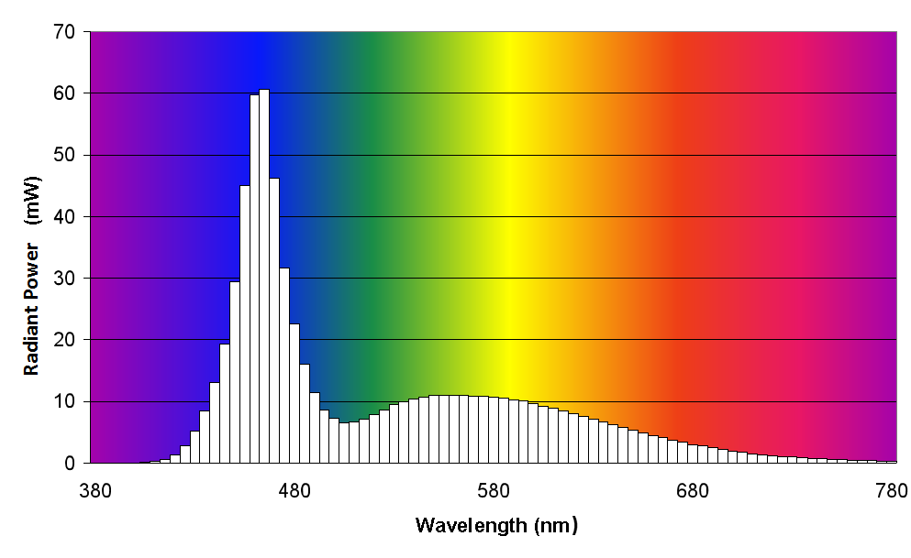

1. Spectral Power Distribution of White LED (5nm intervals)

## Luminous Flux (lumen)

**C**hange in luminous energy with time.

$$Φ_{v}=\frac{dQ_{v}}{dt}$$

1. **Luminous flux**

where $Q_{v}$ is the luminous energy emitted, transferred or received and *t* is time.

Luminous flux is a quantity derived from the radiant flux, $Φ_{e}$, by evaluating the radiation according to its action upon the CIE standard photometric observer. Luminous flux can be derived from the spectral radiant flux distribution by：

$$Φ_{V}=K_{m}\int_{0}^{∞}{Φ_{e,λ}(λ)}V(λ)dλ$$

1. **Derivation of Luminous flux from spectral radiant flux distribution**

where $K_{m}$ is maximum luminous efficacy, $Φ_{e,λ}(λ$)is spectral radiant flux, *V*(*λ*) is spectral luminous efficiency and *λ* is wavelength.

The distribution of the luminous intensities as a function of the direction of emission, e.g. given by the polar angles (ϑ, ϕ), is used to determine the luminous flux, $Φ_{v}$, within a certain solid angle, *Ω*, of a source:

$$Φ_{V}=\iint_{Ω}{I_{v}}(ϑ,φ)sinϑdφdϑ$$

1. **Determination of Luminous flux based on luminous intensity distribution**

The corresponding radiometric quantity is "radiant flux". The corresponding quantity for photons is "photon flux".

The luminous flux is expressed in **Lumen** **(lm).**

## Solid Angle <of an area subtended at a point>(steradian)

***Ω*, $ω$**

Area intercepted on a unit sphere, centred at the point, by a cone having the given area as its base and the point as its vertex.

Seen from the centre of a sphere, a solid angle is the angle that includes a given area on the surface of that sphere. The value of the solid angle is numerically equal to the size of that area divided by the square of the radius of the sphere.

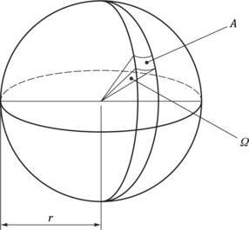

1. Calculation diagram of Solid Angle

*Ω*= A/r2

1. **Determination of solid angle**

Where *Ω* is the solid angle, expressed in steradian (sr) and A is the area of the surface contained in a sphere by a cone with the center of the sphere as its vertex.

Example 1: In a sphere of 1 m radius, 1 sr will describe an area of 1 m2 on the sphere’s surface.

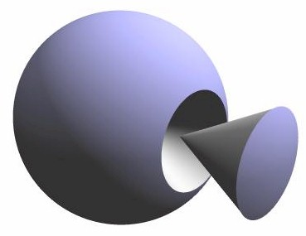

1. Diagram of the corresponding Solid Angle of 1 sr

Example 2: Imagine a sphere of 1 m radius, with an isotropic point source at its centre and a luminous intensity of 1 cd in each direction. The illuminated surface area of the sphere over a solid angle of 1 sr is 1 m2. The luminous flux within that solid angle is 1 lm. The illuminance incident on that surface is 1 lm/m2 or 1 lx.

## Luminous Intensity (candela)

***Iv*；*I***

Density of luminous flux with respect to solid angle in a specified direction.

$$I_{v}=\frac{dΦ_{v}}{dΩ}$$

1. Luminous intensity

Where $Φ_{v}$ is the luminous flux emitted in a specified direction, and *Ω* is the solid angle containing that direction.

For practical realization of the quantity, the source is approximated by a point source.

The distribution of the luminous intensities as a function of the direction of emission, e.g. given by the polar angles (ϑ, ϕ), is used to determine the luminous flux, $Φ_{v}$, within a certain solid angle, *Ω*, of a source, as shown in equation 5.

Luminous intensity can be derived from the spectral radiant intensity distribution by:

$$I_{V}=K_{m}\int_{0}^{∞}{I_{e,λ}(λ)}V(λ)dλ$$

1. Derivation of luminous intensity from spectral radiant intensity distribution

Where $K_{m}$ is maximum luminous efficacy, $I_{e,λ}(λ)$ is the spectral radiant intensity at wavelength *λ*, and *V*(*λ*) is spectral luminous efficiency.

The corresponding radiometric quantity is "radiant intensity". The corresponding quantity for photons is "photon intensity".

The luminous intensity is expressed in **candela (cd = lm****·sr−1)**

**Candela** is the base unit of the SI for photometry and is defined as follows:

*The candela, symbol cd, is the SI unit of luminous intensity in a given direction. It is defined by taking the fixed numerical value of the luminous efficacy of monochromatic radiation of frequency 540 × 1012 Hz, Kcd, to be 683 when expressed in the unit lm*·*W–1, which is equal to cd*·*sr*·*W–1, or cd*·*sr*·*kg–1*·*m–2*·*s3, where the kilogram, metre and second are defined in terms of h, c and Δ $ν_{Cs}$.*

### Angular luminous intensity distribution

The **angular** **luminous intensity distribution** is a function of the intensity depending on the direction, expressed by *I*($θ$*, $ϕ$*). ($θ$*, $ϕ$*) is the two angles representing the direction(for instance vertical angle $θ$ and horizontal angle $ϕ$). See the coordinate system for spatial orientation shown in 5.2.

Maximum, average and 10th Percentile intensities can be read from an angular luminous intensity distribution, as well as beam divergence angles.

### Time dependent luminous intensity distribution

The variation of the luminous intensity I in a certain direction with time t, expressed as I(t).

Peak Intensity, integrated intensity and effective intensity can be read or calculated from a time dependent intensity distribution.

### Fixed Intensity

### Continuous Intensity

### *I*cont

The luminous intensity of a light source that emits continuous and stable light while maintaining a consistent color.

### Maximum Intensity

***I***max

The maximum luminous intensity on a specified plane in the angular luminous intensity distribution.

### Reference Intensity

***I***0

The luminous intensity on the reference axis or reference plane.

### Peak Intensity

***I***peak

The maximum value of instantaneous intensity reached within the time duration of a flash of light.

### 10th Percentile Intensity

***I***10%ile

The intensity exceeded by 90% of all intensity measurements within a given plot. The 10th percentile line is that which divides the lowest 10% and the highest 90% in any given population.

The 10th percentile intensity is used to describe the horizontal intensity distribution of an omnidirectional horizontal light (fan beam).

### Time-Integrated Intensity

*J*int

The integral of instantaneous intensity with respect to time within a flash of light, relating to a photometric quantity of energy:



1. Time-integrated intensity

Where:

*J*int is the time-integrated intensity, expressed in cd·s=lm·s·sr-1;

*I*(*t*) is the instantaneous luminous intensity at time t within a flash of light, expressed in cd.

### Effective Intensity

*I*eff

Luminous intensity of a fixed light, of the same relative spectral distribution as the flashing light,which would have the same luminous range (or visual range in aviation terminology) as the flashing light under identical conditions of observation.

The range at which an observer may just see a light flash may be described in terms of a single parameter which is called the 'effective intensity of the flash. The eye does not analyse the variations of the luminous flux incident upon it during the course of a brief flash but reacts to the total visual impression of the flash of light. In particular,when the flash can just be seen it is possible to obtain a quantitative measure of the effectiveness of its light by comparing it with a steady light, which is also just seen under the same conditions at the same range, and by the same observer. Sufficient consistency is obtained in such observations to permit the evaluation of effective intensity of the flash as the intensity of the fixed light, which is its equivalent for detection at the threshold of visual perception(achromatic threshold).

The effective intensity is defined by the equivalence of fixed and flashing lights at threshold levels, and levels above threshold are not considered. Unless otherwise stated, the evaluations are for single flashes, with the lowest effective intensity of the flashes in a character defining the nominal range of that light.

## Luminance

**Deprecated: Photometric brightness**

*L*

Density of luminous intensity with respect to projected area in a specified direction at a specified point on a real or imaginary surface.

$$L_{V}=\frac{dI_{V}}{dA}\frac{1}{cos α}$$

1. Luminance

Where $I_{V}$ is luminous intensity, *A* is area and *α* is the angle between the normal to the surface at the specified point and the specified direction.

Note 1:Standard unit of luminance is **candela per square meter (cd/m2)**.  
(also called **Nits** in the USA, from Latin ‘nitere’ = ‘to shine’).

Note 2:There are several older units of luminance that have now been superseded:

1. Older units of luminance

|  |  |  |  |
| --- | --- | --- | --- |
| Apostilb (deprecated) | 1 asb | = | 1/π cd/m2 |
| Blondel (deprecated) | 1 blondel | = | 1/π cd/m2 |
| Candela per square foot | 1 cd/ft2 | = | 10.764 cd/m2 |
| Candela per square inch | 1 cd/in2 | = | 1550 cd/m2 |
| Footlambert (deprecated) | 1 fL | = | 3.426 cd/m2 |
| Lambert (deprecated) | 1 L | = | 104/π cd/m2 |
| Nit | 1 nit | = | 1 cd/m2 |
| Skot (deprecated) | 1 skot | = | 10-3/π cd/m2 |
| Stilb (deprecated) | 1 sb | = | 104 cd/m2 |

## Illuminance [31]

**Deprecated: ILLUMINATION**

*Ev; E*

Density of incident luminous flux with respect to area at a point on a real or imaginary surface.

$$E_{V}=\frac{dΦ_{V}}{dA}$$

1. Illuminance

Where $Φ_{V}$ is luminous flux and *A* is the area on which the luminous flux is incident.

Note 1: Illuminance can be derived from the spectral irradiance distribution by:

$$E_{V}=K_{m}\int_{0}^{∞}{E_{e,λ}}(λ)V(λ)dλ$$

1. Derivation of illuminance from spectral irradiance

where Km is maximum luminous efficacy, $E_{e,λ}(λ)$ is the spectral irradiance at wavelength *λ* and $V(λ)$ is spectral luminous efficiency.

Note 2: The corresponding radiometric quantity is "irradiance". The corresponding quantity for photons is "photon irradiance".

Note 3: Standard unit for illuminance is **Lux (lx),** or lumens per square meter (lm/m2).

Note 4: There are also several older units of illuminance that have now been superseded:

1. Older units of illuminance

|  |  |
| --- | --- |
| footcandle | 1 fc = 10.764 lx. |
| dalx (in Canadian safety regulations) | 1 dalx = 10.764 lx. |
| phot | 1 ph = 10,000 lx |

A surface will receive lx of illuminance from a point light source that emits 1 cd of *luminous intensity* in its direction from a distance of 1 m. When using the non-standard US units, this translates into 1 fc received from a 1 cd source 1 ft away.

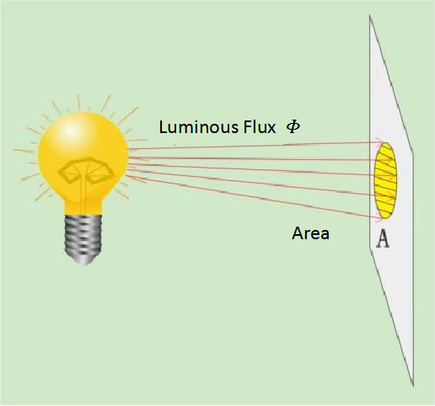

1. Diagram of illuminance

## Beam Divergence

**Beam Divergence** (sometimes called beam spread) describes the angle between the two directions opposed to each other over the beam axis. Limits of divergence are set where the luminous intensity falls to a certain fraction of that of the reference intensity within the beam. For aid-to-navigation beacons, horizontal and vertical divergences are usually quoted.

When used to describe the **vertical** spread of a beam, the vertical divergence is usually given two angles, upper and lower. These are given plus and minus figures respectively in accordance with measurement geometry (see section 10.1.1)

It is normal practice to quote the angle between the two directions opposed to each other over the *beam axis* for which the *luminous intensity* is half that (50%) of the reference luminous intensity (sometimes referred to as the *Beam Angle***)**. The angle between these 50% points is sometimes called full-width at half maximum—FWHM. It is recommended that FWHM is used when quoting beam divergence

Sometimes, the angle between the two directions opposed to each other over the *beam axis* for which the *luminous intensity* is one-tenth that (10%) of the reference luminous intensity (sometimes referred to as the *Field Angle*) is quoted. The angle between these 10% points is sometimes called full-width at tenth maximum—FWTM. When FWTM is used instead of FWHM, it should be clearly stated.

When the luminous intensity points are other than half of reference, the fraction or percentage of reference should be quoted.

Due to the possible asymmetry in the actual luminous intensity distribution, the value of the beam divergence is twice the smaller of the two angles formed between the corresponding rays with the reference axis or reference plane, where the intensity drops to 50% (when using FWHM) or 10% (when using FWTM) of the reference intensity (see 10.1.1), i.e., FWHM = 2 x min{ΔH1 , ΔH2}, FWTM = 2 x min{ΔT1 , ΔT2}.

 

1. Symmetric distribution (b)Asymmetric distribution
2. Beam Divergence

## Critical Flicker Frequency OR Fusion Frequency

For a given set of conditions, the frequency of alternation of stimuli above which flicker is not perceptible.

This is the frequency above which the human eye perceives a flickering light source to be steady. Humans have a flicker fusion frequency of 60 Hz in bright light and 24 Hz in low light.

## Crossover Distance

The distance at which a beam of light is fully developed.

The divergent rays from the extremities of the optical aperture meet at crossover distance(see Figure 26). At this distance, the image of the light source will fully fill the aperture of the optical apparatus.

## Measurement Distance

The physical distance between the light source being measured and the aperture of the measuring instrument. Where a curved mirror are being used, as in Zero-Length Photometry (see ANNEX B) the effective measurement distance may be different from the physical distance between light source and measuring instrument.

## Measurement Angle

The angle subtended by the measurement aperture over the measurement distance (see section 8.7).

## Limiting Photometric Distance

The minimum distance in a given direction from a light source at which the photometric distance law holds.

The minimum photometric distance depends on the required accuracy, the beacon and the photometer. In many cases an exact definition cannot be stated.

For sector projector, the crossover distance can be used as the limiting photometric distance (see section 8.6).

## **Root-mean-square value**

**RMS value**

**Effective value**

For a time-depending quantity, positive square root of the mean value of the square of thequantity taken over a given time interval.

The root mean square or rms is a statistical measure of the magnitude of a varying quantity. It can be calculated for a series of discrete values fi or for a continuously varying function f(t). The name comes from the fact that it is the square root of the mean of the squares of the values.

When f(t) is a function of time then the root mean square for a time interval [t1, t2] is:

1. Root mean square for a time interval

When f(t) is a discrete function fi for equally spaced times ti = i*Δt then the integral can be replaced by a sum:

$$RMS=\sqrt{\frac{1}{N}x\sum_{i=0 to N}{{f_{i}}^{2}}}$$

1. Root mean square for equally spaced time intervals

Where:

N * Δt = t2 - t1

It is recommended to use the RMS-value for electrical voltage, current and power, when a beacon has AC power supply.

## Goniometer

Device used for producing or measuring angular rotations.

In the context of photometry and radiometry a goniometer is typically a mechanical structure consisting of two mutually orthogonal axes that rotate a source and/or a detector about a common reference point in space.

## GonioPhotometer [19]

Photometer for measuring the directional light distribution characteristics of sources, luminaires, media or surfaces.

Goniophotometer is a combination of a goniometer and photometer. The practice of measuring luminous values with reference to geometric angle is called goniophotometry.

## **Goniospectroradiometer**

Measuring system that has the capability to measure spectral radiant quantities in different directions from the source.

Note 1: Photometric quantities and colorimetric quantities can be derived from the data obtained by goniospectroradiometer.

Note 2: Goniospectroradiometer is a combination of a goniometer and spectroradiometer.

## Colorimetry

Measurement of colour stimuli based on a set of conventions.

The word **colorimetry** is derived from Latin: *color* = colour and Greek: *metron* = measure. It is the science of measuring colour. There are broadly two types of colorimetry, the measurement of surface colours, such as painted metal, that are illuminated by incident light; and the measurement of light emitting objects, such as lamps.

The colorimetry of light sources is usually confined to describing colours as a series of numbers, typically as chromaticity coordinates giving the location of a point within a model of two-dimensional colour space (see 4.20, 4.21). The resultant colour coordinates describe a colour, but not how bright the light is.

## **CIE standard colorimetric observer**

Standard colorimetric observer defined by the CIE colour-matching functions.

In 1931, the CIE developed three colour matching functions labelled ****,  and , known as CIE 1931 standard colorimetric system. The ideal observer whose colour-matching properties correspond to the CIE colour-matching functions adopted by the CIE in 1931 is CIE 1931 standard colorimetric observer.

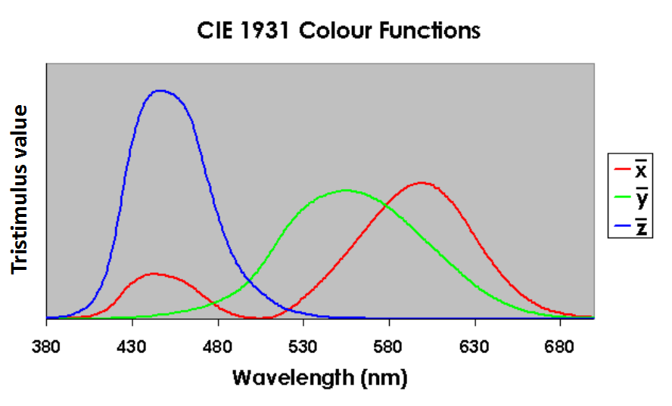

1. The CIE 1931 Standard Colour Observer

## **Tristimulus values, <of a colour stimulus>**

Amounts of the reference colour stimuli, in a given trichromatic system, required to match the colour of the stimulus considered.

In the CIE standard colorimetric systems, the tristimulus values are represented, for example, by the symbols *R*, *G*, *B*; *X*, *Y*, *Z*.

In the measurement of AtoN navigation light, tristimulus values *X*, *Y*, *Z* corresponding to the CIE 1931 standard colorimetric system are used, and the calculation formula shown in equation 15:

$$X=k\sum_{380}^{780}{S_{t}(λ)\overline{x}(λ)△λ}$$

$$Y=k\sum_{380}^{780}{S_{t}(λ)\overline{y}(λ)△λ}$$

$$Z=k\sum_{380}^{780}{S_{t}(λ)\overline{z}(λ)△λ}$$

$$k=\frac{100}{\sum_{380}^{780}{S_{t}(λ)\overline{y}(λ)△λ}}$$

1. Tristimulus values *X*, *Y*, *Z*

Where $S_{t}(λ)$ is the relative SPD of the AtoN navigation light; $\overline{x}$ ($λ$), $\overline{y}$ ($λ$) and $\overline{z}$ ($λ$) are the color matching functions of CIE 1931 standard colorimetric observer; $△λ$ is the wavelength interval; and k is a normalized constant.

## **Chromaticity coordinates**

Coordinates expressing the quotients of each of a set of three tristimulus values and their sum.

In the CIE 1931 standard colorimetric system, for a given SPD, the final results of the weighted integrals using $\overline{x}$ ($λ$), $\overline{y}$ ($λ$) and $\overline{z}$ ($λ$) are X, Y, and Z, respectively (see 4.22); in order to plot the color of a light source on a two-dimensional x, y chromaticity diagram, they can be simplified into two values as:

$$x=\frac{X}{X+Y+Z}$$

1. Chromaticity coordinate x
$$y=\frac{Y}{X+Y+Z}$$

2. Chromaticity coordinate y

Where x and y are chromaticity coordinates in the CIE 1931 standard colorimetric system (XYZ); X, Y and Z are the tristimulus values in the CIE 1931 standard colorimetric system.

Note 1: As the sum of the three chromaticity coordinates is equal to 1, two of them are sufficient to define a chromaticity.

Note 2: In the CIE standard colorimetric systems, the chromaticity coordinates are represented by the symbols x, y, z.

Note 3: The chromaticity coordinates have unit one.

## Chromaticity [24]

Property of a colour stimulus defined by its chromaticity coordinates, or by its dominant or complementary wavelength and purity taken together

It is usually quantified by plotting a point, given as two coordinates, in a two-dimensional colour model space. An example is a chromaticity diagram, the plane diagram in which points specified by chromaticity coordinates represent the chromaticities of colour stimuli.

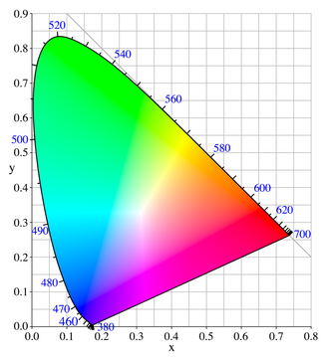

1. The CIE 1931 Chromaticity Diagram

The colour space is bounded by the spectral locus where monochromatic wavelengths are shown in units of nanometres (blue numbers). The CIE 1931 x, y chromaticity diagram is the most commonly used for plotting the colour of light sources.

## Color temperature

**Tc**

Temperature of a Planckian radiator whose radiation has the same chromaticity as that of a given stimulus.

The colour temperature of a traditional incandescent light source is determined by comparing its hue with a theoretical, heated black-body radiator. The lamp's colour temperature is the temperature in degrees Kelvin at which the heated black-body radiator matches the hue of the lamp.

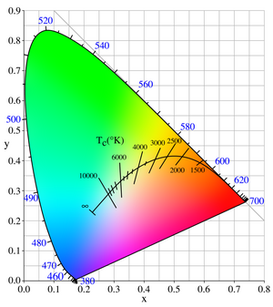

1. CIE x, y Chromaticity Diagram Showing Color Temperature

## Correlated Colour Temperature[24]

Temperature of a Planckian radiator having the chromaticity nearest the chromaticity associated with the given spectral distribution on a modified 1976 UCS diagram where *u*′, $\frac{2}{3}$*v*′ are the coordinates of the Planckian locus and the test stimulus.

The Planckian locus is the path that a black body colour takes through the chromaticity diagram as the black body temperature changes. Lines crossing the locus indicate lines of constant ‘correlated colour temperature’ (CCT).

## Response time

Time required for the change in detector output to reach, after a step variation of a steady detector input, a specified percentage of its final value.

Rise time is the time required for a detector output to rise from a stated low percentage to a stated high percentage of the maximum value when a steady input is instantaneously applied; and fall time is the time required for an output to fall from a stated high percentage to a stated lower percentage of the maximum value when a steady input is instantaneously removed.

Note 1: In essence, response time is a measure of the measuring equipment's ability to faithfully follow its input signal. When measuring the rapidly changing temporal intensity of pulsed light or when measuring the modulation characteristics of a light source (e.g., PWM modulation), the response time of the detector should be faster than the rise time or fall time of the flash curve.

Note 2: Response time can be relevant for goniometers when intensity measurements are carried out whilst the goniometer is moving. It relates to the time interval between the angular steps, in other words, how long it takes the goniometer to move from one angular position to the next. The relationship between the time taken to carry out an intensity measurement and the speed of rotation of the goniometer can give an angular error. The error can also be corrected by the predicted response time.

## **Photometric centrE**

Point in a source from which the photometric distance law operates most closely in the direction of maximum intensity.

## **Reference center<of the DUT>**

The point related to (usually within) the DUT to be placed at the goniometer reference point.

Ideally, this should be the photometric centre of the DUT. However, the exact photometric centre can be unknown, can require extensive measurements to determine, and can vary with wavelength or angle. In such cases, a more practical DUT reference centre, based on the device geometry and the size, shape and position of the light source within the DUT, can be used (see 8.3, 8.5).

# MEASUREMENT PRINCIPLES

## Photometric Distance Law

According to the Photometric Distance Law proposed by Lambert in 1760, the illuminance is inversely proportional to the square of the distance to the point light source. In the case of oblique light, the illuminance is directly proportional to the cosine of the angle between the beam direction and the normal of the illuminated surface. The illuminance on the receiving surface of the illuminance meter is determined by:

$$E=I∙\cos{θ/d^{2}}$$

1. Photometric Distance Law

Where

 is the illuminance on the receiving surface of the illuminometer, whose standard unit is Lux ( lx ),

 is the luminous intensity of the measured AtoN light, whose standard unit is candela ( cd ),

 is the distance from the light source center of the measured AtoN light to the receiving surface of the illuminometer, whose standard unit is meter ( m ),

 is the included angle between the beam in the measured direction of the AtoN light and the normal of the receiving surface of the illuminometer.

When using a goniophotometer to measure luminous intensity,  is generally equal to zero, so equation 18 becomes:

$$I=d^{2}E$$

1. Photometric Inverse Square Law

The measurement of luminous intensity is carried out by measuring the illuminance produced by a beacon at a distance *d* away from a photoreceptor and then determined by equation 19.





1. Photometric Distance Law

The arrangement above can be modified by introducing a folding mirror or by using Zero-Length Photometry (see ANNEX A).

## Coordinate systems

When measuring and describing the distribution of light intensity with respect to angles, it is essential to have a well-defined coordinate system to describe spatial angles. Additionally, this coordinate system is closely linked to the scanning measurement procedure of the photometric device. The system used is a spherical coordinate system with the centre coincident with the DUT reference centre.、

CIE ([19], 121) provides three common coordinate systems, namely the A/α coordinate system, B/β coordinate system, and C/γ coordinate system, as illustrated in Figure 13. It also specifies the arrangement of the rotation axis for the goniophotometer. From a general point of view the coordinate system consists of a set of planes with a single axis of intersection. A direction in space is characterised by two angles:

-the angle between one half-plane, taken as an origin, and the half-plane containing the direction considered ((the angle of the plane);

-the angle between the axis of intersection and the direction considered or the complement of this angle (the angle within the plane).

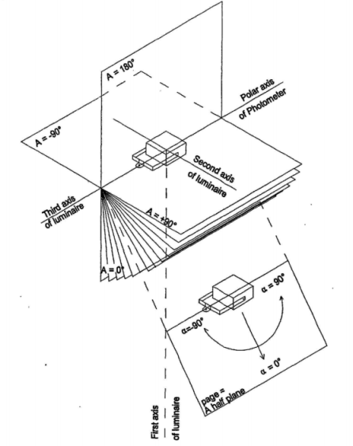

(a) A/α coordinate system

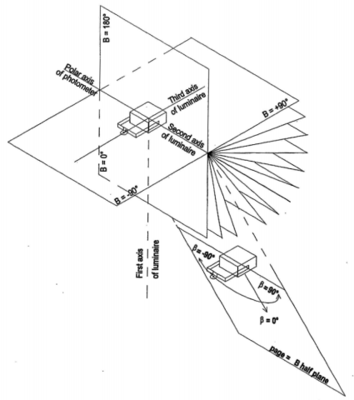

(b) B/β coordinate system

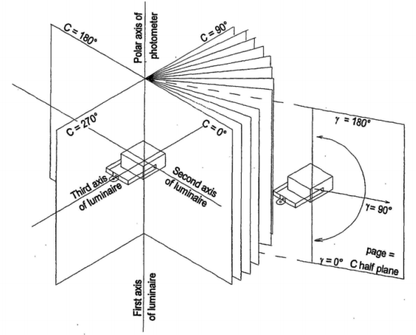

(c) C/γ coordinate system

1. Three Types of Coordinate Systems

Coordinate transformations can also be performed between different coordinate systems.

For navigation light measurements, it is recommended to use the A-α coordinate system, and a typical goniophotometer is illustrated in Figure 13. The light source under measurement is tilted around a fixed horizontal axis and rotated around a vertical axis.

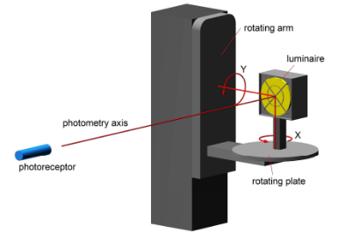

1. *Typical Goniophotometer of the A-*α *Coordinate System*

## Photometric measurement

### Spectrophotometry Measurement (based on spectrum)

The light is divided into different wavelengths, and the amount of light at each wavelength or wavelength interval is measured by a receiver. This method uses a spectroradiometer for measurement, which is an instrument for measuring radiometric quantities in narrow wavelength intervals over a given spectral region. Depending on their structure, spectroradiometers can be categorized into mechanical scanning and array-based types, as described in sections 5.5.1 and 5.5.2 below. The obtained spectral radiometric values are weighted by the luminous efficiency function *V*($λ$) for photopic vision to obtain photometric values (as defined in section 4.5 for luminous flux, section 4.7 for luminous intensity, section 4.9 for illuminance, etc.).

If the calibration of the spectroradiometer is for spectral radiant flux, use formula 4 in section 4.5 for calculation. If the calibration is for spectral radiance, use formula 8 in section 4.7. If the calibration is for spectral irradiance, use formula 12 in section 4.9.

Spectrophotometric measurements do not have spectral mismatch errors, but it's important to note that wavelength errors and stray light within the spectroradiometer can introduce measurement errors, thereby affecting the accuracy of photometric measurements.

### Integral Method Measurement

Photometers are used to measure photometric quantities by the integral method. A photometer typically comprise a photoelectric sensor, a *V*(*λ*)-correction filter, and a precision aperture.

The *V*(*λ*)-correction filter is applied to make the spectral response of the photometer approximate the CIE standard luminous observer's spectral luminous efficiency function *V*(*λ*) (see section 4.2). The photometer converts incident photons into corresponding currents, and its electrical output is amplified to provide readings that can be calibrated into luminous values.

The output of the photometer is proportional to the photometric quantity. After calibration with a standard reference, the photometer can measure absolute photometric values.

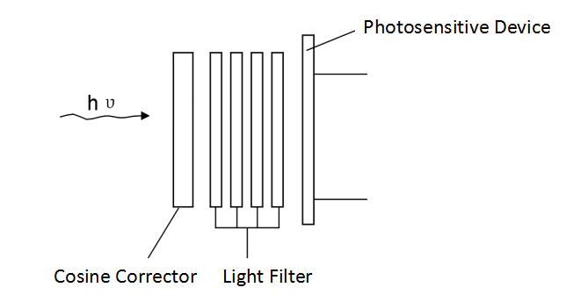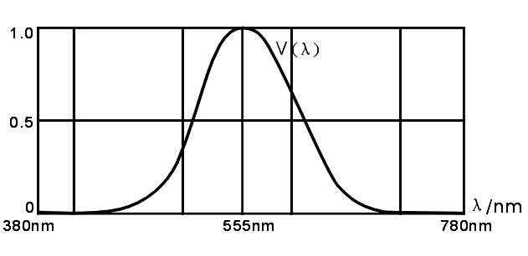

Spectral Response

1. *Diagram of Integral Method in Photometric Measurement*

Errors may occur when measuring a light source of different spectral distribution to the one used to calibrate the photometer because of differences between the spectral response of the photometer and the response of the standard photometric observer *V(λ), as shown in* figure 15. Such errors are called ‘spectral mismatch errors’ and can be quite large at certain wavelengths, typically in the red and blue regions where the photometer is least sensitive. Light sources with a narrow spectral distribution (e.g. coloured LED) are more likely to produce large errors than broad-spectrum white light sources.

Spectral mismatch correction is an adjustment, carried out on the results of a photometric measurement, to correct any errors in the photometer spectral response.



1. Spectral Plot showing Differences between Typical Photometer Response and V(λ)



1. Expanded Section of Spectrum Highlighting Photometric Error in Figure 15

## Colorimetric measurement

### Spectral measurement

After measuring the spectral power distribution of the light stimulus using a spectroradiometer, chromaticity parameters can be calculated using equations 15-17 (see sections 4.22 and 4.23). When measuring chromaticity parameters, it is only necessary to obtain the relative spectral power distribution without requiring absolute values.

Spectral colorimetric methods do not involve spectral mismatch errors, but it's important to note that wavelength errors and stray light within the spectroradiometer can introduce measurement errors, thereby affecting the accuracy of chromaticity measurements.

### Integral method measurement

The method of measuring the color of a light source using a tristimulus colorimeter is called the integral method. A tristimulus colorimeter may be used to measure the colour of a light source. The device consists of three or four photodetectors, each with a filter that approximates one of the three colour functions ,  and . The three outputs are then arranged to give X, Y and Z values, or computed to give x, y chromaticity. Additionally, because the Y function is the same as V(λ), the Y output may be calibrated to give a luminous value (e.g. lux).

Colorimeters are sometimes combined with a luminance meter aperture, often with input optics.

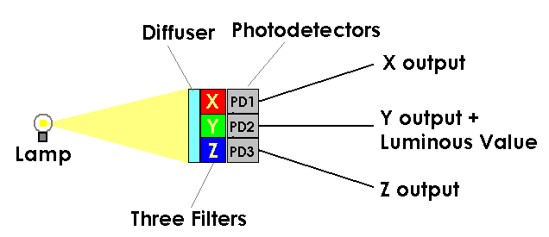

1. Schematic of a simple Tristimulus Colorimeter

Tristimulus colorimeters have the advantage that a relatively fast measurement can be made of colour. However, cheaper models may yield significant errors because the filters do not faithfully follow the colour functions. Such errors are more noticeable when measuring light sources with a narrow spectral distribution. Similar to photometric measurements, spectral mismatch correction can also be employed to reduce chromaticity measurement errors. Alternatively, errors can be minimized by calibrating the readings of the tristimulus colorimeter using light sources with known tristimulus values and the light source should have the similar spectral distribution with the DUT.

## **Principle of spectral measurement**

### Mechanical scanning spectroradiometer

Scanning spectroradiometers combine a monochromator and a single-channel detector. For example , the Czerny-Turner monochromator shown in Figure 18 has a radiometer head (usually a photodiode or photomultiplier tube) coupled to the output slit. The monochromatic light emitted in the exit slit is then measured by the single-channel detector.

Typically, the diffraction grating is turned in increments and a radiometric measurement taken at each incremented step. Such devices are quite slow and may not be suitable for flashing light sources and modulated light sources. They are however, capable of great accuracy but can be prone to mechanical instability and need frequent calibration.

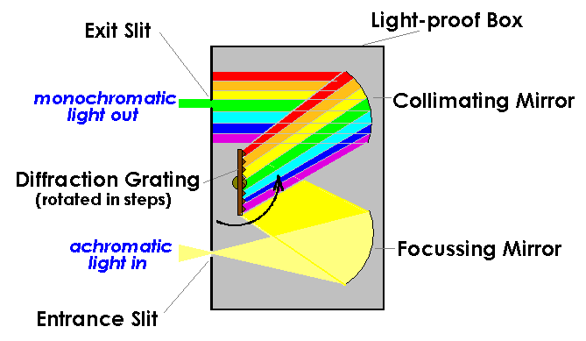

1. Schematic of Czerny-Turner Stepping Monochromator

### Array-based Spectroradiometer

An array-based spectroradiometer uses a monochromator that is fixed and where the output slit is replaced by an array of charge-coupled devices (CCD) that act as individual radiometric receptors for each waveband. CCD record the amount of charge, which is dependent on the exposure time to the light being measured. This exposure time is commonly known as integration time, which can be varied to accommodate varying levels of light input.

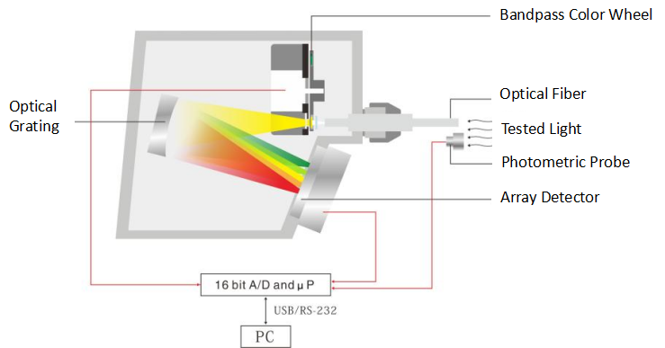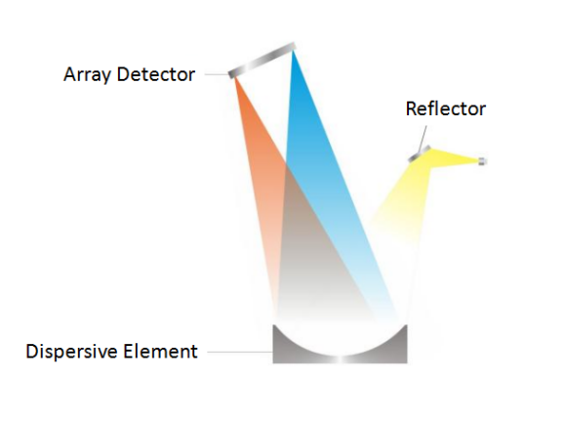

1. *Schematic diagram of array spectroradiometer*

## **Measurement of modulated light**



### Talbot-Plateau Law

The Talbot-Plateau Law states that if a light source is flashed or pulsed at a rate above the critical flicker frequency or flicker fusion frequency, such that it appears as a continuous light, the luminance of the source will be equal to that of a steady light that has the same time-average luminance [4][29].

### Photometric measurements

When using photometers, which typically have a slow response time, to measure the continuous intensity of a light flickering or pulsing above the flicker fusion frequency, the photometer output may need to be time-integrated to ensure that the Talbot-Plateau Law is obeyed.

Or use a fast photometer to capture the waveform, and then calculate to obtain the average value of light.







.

### Spectroradiometer measurements

Mechanical scanning spectroradiometers are not suitable for measurements of modulated light. When using an array spectroradiometer, the entire modulation period should be taken for measurement.

## Effective intensity of rhythm light

The effective luminous intensity of the rhythmic light $I_{eff}$ is calculated according to the Modified Allard Method (MAM) using the convolution method (see [40], [41]) .

When MAM is used to process asymmetrical flash waveforms such as triangular waves, the predicted results are different from those actually observed by observers in visual experiments [42], [43]] . This means that the MAM visual impulse response function can be further improved to improve accuracy.

Couzin D. improved the MAM impulse response function model [ 44 ] , so that when it is used to deal with the complex waveforms mentioned above, the theoretical calculation results are more consistent with the experiments .

## Absolute photometry and relative photometry

For all types of beacon lights, their luminous intensity and luminous intensity distribution ( unit : cd ) can be obtained by direct measurement, and this method is called absolute photometry.

However, in traditional beacon lights, the light source can often be replaced, and the relative method can also be used when evaluating its luminous intensity. That is, when measuring the beacon light , use the light source specified by the manufacturer to measure, and measure the total luminous flux of the light source included, and calculate the relative luminous intensity, the unit is cd/klm. The total luminous flux of the light source can be obtained by an integrating sphere photometer. When the light source in the navigation light is attenuated or replaced (with a light source of the same , the corresponding luminous intensity value can be quickly calculated through the relative luminous intensity.

With the application of LED light sources in navigation lights, more and more light sources are integrated in navigation lights and cannot be replaced. The scope of application of relative photometry is increasingly limited, and absolute photometry is more common .

# MEASUREMENT EQUIPMENT

## Equipment configuration/general rules

The measuring equipment for measuring the optical performance of the beacon light is mainly a goniophotometer, which is mainly composed of a goniometer, a photometer, and a measurement signal processing system. The photometer can also be replaced by a spectroradiometer to form a goniospectroradiometer . Integral calculations yield photometric and chromatic values. In addition, colorimeters, folding mirrors, and calibration light sources may also be involved.

## Photometer REQUIREMENT





The spectral response of the photometric system should closely approximate the spectral luminous efficiency curve V(λ) for the CIE standard photometric observer in photopic vision (see 4.2).

The $V(λ)$ mismatch index ${f_{1}}^{’}$ [6] should be less than or equal to 6%, and , the linearity should be higher than 1%.

The measurement sensitivity should be appropriate to respond to the expected signal without saturating. For example, if measuring a light with an expected intensity of 100 cd at a measurement distance of 10 m, the photometer will receive an illuminance of 1 lux. A photometer with a sensitivity of 0.01-2 lux might be selected.

Most photometers are calibrated using illuminant A, so when using a photometer to measure light with a spectral distribution different from that of illuminant A (such as colored lamps or discharge lamps), spectral mismatch correction is recommended (see 5.3.2, 8.4 ).

Photometers include two types:

a. The conventional photometer, which obtains the average value of the modulated light when measuring the modulated light, should have a low dependence on the modulated light. The modulated light index $f_{7}$ at 100 Hz is less than or equal to 0.1%, and the modulated light index at 40 Hz and 100000 Hz ${f_{7}}^{’}$ is less than or equal to 5%;

b. Fast photometer, measuring the instantaneous value of light character, its response time should not be greater than 10 μs. The sampling frequency should be sufficiently high to capture the waveform without aliasing. When using a discreet photometer head and sampling device, a low pass filter set to less than or equal to 50 % the sampling frequency should also be used. For example, a light modulated at a frequency of 100 Hz might be measured using a sample rate of 1 kHz and, where appropriate, a low pass filter of 500 Hz.

## Goniometer

For the recommended goniometer, see 5.2.

Angle range should meet: A plane -180°～180°, α from -90°～90°; angle accuracy should be within ±0.05°; minimum angle measurement step should not be greater than 0.1°.

A method of determining the uncertainty in the positioning mechanisms of the goniometer should be documented, and the stated uncertainty in angular displacement evaluated. It should be noted that when the goniometer table is tilted, the measurement distance from the top and bottom of the DUT changes and this can lead to a measurement error. This error may be corrected or treated as an additional uncertainty .

## ‘Folding’ Mirror

When the limiting photometric distance (see 4.15,8.6) exceeds the maximum optical path length of the available measurement space, one or more plane mirrors, sufficiently large as to generate a full image of the item under test, may be placed at the end of the light path. The photometer may be used to measure the light signal reflected from the mirror. It is recommended to use a front-surfaced mirror with a very accurate flat surface, high reflectance and flat spectral reflectance to minimize losses and geometrical distortion of the reflected image.

However, the use of a mirror may result in a change to the spectral correction factor, SCF (see section 8.4). Measurement of a reference source, directly and over the folded path, of similar spectral output to the DUT, may be used to determine overall losses and spectral distortion produced by the mirror. If the minimum measurement distance still exceeds the folded measurement length, measurements should be made using one of the two methods described in ANNEX A and ANNEX B.



1. Folding Mirror Schematic

It is recommended that the photoreceptor be close to the beacon under test. For this the reflecting angle of the mirror is very small and the path between beacon and mirror equals approximately the path between the mirror and the photoreceptor.

The reflection angle of the mirror should be as small as possible to reduce the influence of polarization; more than one mirror can be set to return the light path. The diameter of the folding mirror should be slightly larger than the cross-sectional size of the optical path formed at this position .

Care must be taken to avoid stray light. Use light barriers, and block light-mirror reflections.



## Tristimulus Colorimeter [32]

A method for carrying out a colour measurement using a tristimulus colorimeter is given in ANNEX C.

Since the spectral response matching of a tristimulus value colorimeter is generally poor, it is only recommended to use this instrument to measure the relative change of color, and a spectroradiometer is recommended for higher accuracy color measurement.

## Spectroradiometer

The spectroradiometer wavelength range should cover at least 380 nm to 780 nm, the bandwidth (FWHM) should not be greater than 5 nm, the wavelength accuracy should be better than ±0.5 nm, the spectroradiometer linearity in the visible light band should be higher than 1%.

The geometry of photometric or chromatic measurements using a spectroradiometer is shown in ANNEX D.

## Calibration Light Sources [30]

Calibration light sources, calibrated at a national standards laboratory, and traceable to the national standard, are sometimes known as ‘standard lamps’, ‘standard reference lamps’ or ‘transfer standards’. The calibration light source is very stable and can be used as a reference in photometric or spectroradiometric measurements such as common and general calibration light sources incandescent lamps or tungsten halogen lamps matching CIE standard illuminant A with absolute spectral values. In addition, there are common standard lamps such as luminous flux standard lamps, luminous intensity standard lamps, spectral irradiance standard lamps, etc., which can be used to calibrate luminous flux, luminous intensity or spectral irradiance .

Such lamps require stable power supplies and require their voltage and current to be measured with low uncertainty. The equipment used to measure their voltage and current should also be traced back to the national standard. Calibration certificates must include not only the corresponding value but also the uncertainty of the value.

# GENERAL **Measurement Condition**S

## **Test classification**

According to the environment/conditions for measuring the light performance of navigation lights, it can be divided into two types: laboratory measurement and field measurement. Laboratory measurement is the measurement of typical samples under controllable standard conditions, with high measurement accuracy. This chapter mainly describes some environment and power supply requirements in laboratory measurement.

Field measurement is the measurement of lamps or light sources in the on-site environment, which is greatly affected by environmental factors and alignment and measurement equipment. The measurement uncertainty is relatively large, and environmental conditions need to be documented.

In addition, estimates can also be made based on optical design parameters . For projection sector lamps, a particularly long optical path is required, and it is difficult to actually measure in the laboratory. The relevant parameters can be estimated according to the design parameters and component measurements (another guideline document)

## Requirement for DUT

The item to be tested or measured should be checked to ensure that it is in good operating condition. Its optical system should be outfitted with the appropriate light source, which may be supplied by the manufacturer or be a standard laboratory test lamp if the light source is separable, and focused (if required) in accordance with the manufacturer’s instructions or standard laboratory procedure.

Laboratory test lamps should be selected for close conformance to design dimensions, rated power consumption, and rated lumen output. Manufacturing tolerances between individual lamps of the same manufacturer’s specification may be very large causing a correspondingly large variation in the intensity of a beacon. Parameters such as filament coil spacing and size also impact greatly on the intensity distribution, therefore close inspection and selection is recommended. A test procedure should be written to ensure conformance of laboratory test lamp properties within 3% of the manufacturer’s specification [11].

When a lampchanger is included as part of the test item, lamps should be installed in all positions of the lampchanger where they might impact on the photometric output of the item under test. Lamps should be seasoned by running them for a few tens of hours prior to initial use [11]. Note that all light sources, particularly LEDs and discharge lamps, may require several hundred hours of operation (ageing) prior to being used for measurement purposes.

## Environmental Conditions

Ambient conditions for indoor measurements maintain a relative humidity of 10 % to 65% . For LED light sources, the ambient temperature should be stabilized at 25.0 °C ±1.2°C ; for other types of light sources, it should be stabilized at 25.0 ° C ±3.0° C . There is no interference such as smoke, dust, water vapor, mechanical vibration, electromagnetic and light that affect the test accuracy. The laboratory should be in a dark room environment, and the walls in the dark room should be painted with matte black paint. The test equipment, baffles and other test accessories should be non-reflective. Measurements should be made in still air with a margin of error of 0 m/s to 0.25 m/s .

If the above temperature conditions cannot be met, it is recommended to use a "service conversion factor" to correct the results for measurements outside the acceptable ambient temperature range. If the client specifies a declared ambient temperature for the EUT other than 25.0°C, unless the measurement was made at that specified temperature, the measurement at 25.0°C shall first be reported, and then a service conversion factor shall be established to convert the measured value at 25.0°C to Converted to the value at the specified ambient temperature. The service conversion factor can be obtained by measuring the ratio of the total luminous flux (or light intensity or brightness in a fixed direction) of the device under test in a temperature-controlled box or a temperature-controlled measurement system (such as a temperature-controlled integrating sphere), and report the service conversion factor separately. If the service conversion factor cannot be experimentally determined by itself, performance curves can also be obtained from the LED manufacturer and adjusted in this way. Figure 21 below is an example performance graph.

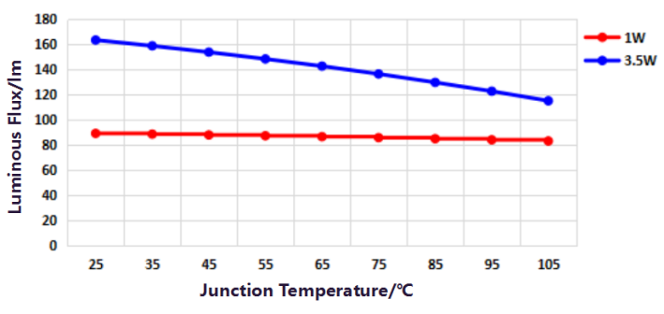 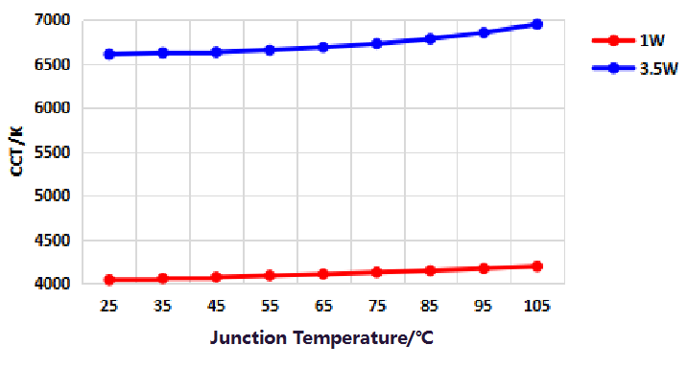

(a) Variation of photometric and colorimetric performance with junction temperature of white LEDs with different power levels

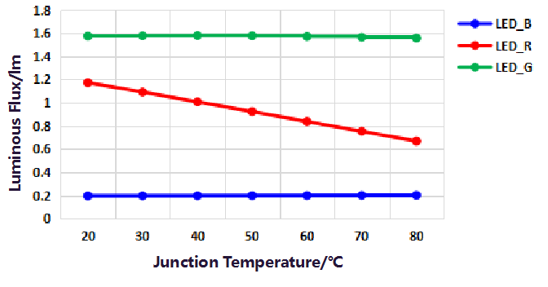 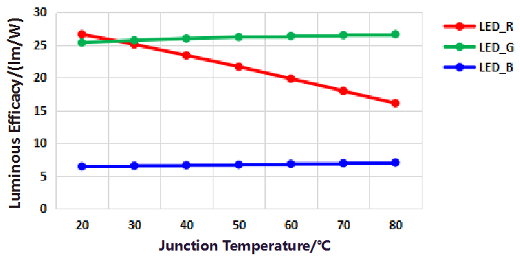

(b) Variation of photometric and colorimetric performance with junction temperature of monochrome LEDs

1. *Schematic diagram of LED light color performance changing with temperature*

When applying these graphs, it must be assumed that the change in luminous flux is linear with the range of the dependent variable and that the junction temperature varies directly with the ambient temperature. But that may not be the case, especially given the flickering lights at sea. On average, however, the service conversion factor based on the data sheet may be sufficient.

In the case of outdoor measurements, the temperature and relative humidity should be noted at the time of the measurement. Any significant changes in ambient conditions during the measurement should be recorded.

## Power/Electrical Conditions

Marine aid-to-navigation light signals should be tested at rated voltage, rather than current or power. For tests involving equipment powered by a dc power supply, the output voltage and/or current should be maintained within ± 0.2% or better, unless otherwise specified by the person requesting the measurement. When output voltage is controlled, the voltage should be monitored as close to the light source as possible. Ripple voltage should not exceed 0.4% of the DC output voltage.

For tests involving equipment powered by an external ac power supply, the output RMS voltage or current should be maintained within ± 0.4%. If the rated value is within a range, the middle value shall be taken. The AC power supply should have a specified frequency (50 Hz if there is no special instruction) sinusoidal voltage waveform. The RMS summation of the harmonic components, caused by departures from a true sinusoidal waveform, should not exceed 3% of the RMS value of the fundamental frequency. Readjustment of the output voltage may be required during measurements if adequate stabilization is not achieved.

The voltage should be monitored, with sense leads attached as close as practical to the lamp inputs or controlling circuitry inputs, and kept constant throughout the measurement process. Current should also be monitored and recorded, to detect any changes in the input power during measurements and allow for correction of measured photometric output (see section E.6).

## Equipment Warm-up

All test equipment requiring electrical power should be switched on and allowed to warm up in accordance with the manufacturers’ operating instructions or calibration certificates before commencement of any tests or measurements. In the absence of such guidance, the measurement facility should evaluate the performance of test equipment to determine the required warm up period to prevent drift for each piece of equipment.

Items under test should be run at rated power for a sufficient period to ensure stability. The warm-up time selected for any type of light source should be documented in the laboratory procedures, and used consistently.

Before measurement, the measured AtoN light shall be operated under the specified character for a long enough time to achieve photometric, electrical stability and temperature balance. The AtoN light shall operate under the conditions specified in 3.2.1 (2) during warm-up. The photometer is used to continuously monitor the output of the measured AtoN light, which can be determined as stable when the following conditions are met:

1. Under the steady light state, the photometric value is measured every 5 minutes. After three consecutive measurements, the variation between the maximum and minimum results is less than 0.5% of the minimum result.
2. In the rhythmic light state, a fast photometer is used to measure and calculate the effective intensity according to 3.1.2 every 5 minutes. After three consecutive measurements, the variation between the maximum and minimum results is less than 0.5% of the minimum result.

When the AtoN light under measurement is switched to a different light character or color for subsequent measurement, the stability shall be judged again according to the above conditions before measurement. Record the stabilization time for each measurement.

## Stray and Ambient Light Control

Stray light control includes eliminating reflected light of the item under test, from walls, floors, and other surfaces, from reaching the photodetector. Ambient light control includes eliminating or reducing the amount of light from sources other than the item under test. The impact of ambient light may be determined by removing power to the item under test and recording the output of the photodetector. The impact of both elements may be determined by taking measurements with the item under test on, but with the direct light path occluded by a screen just larger than the light source aperture.



1. Stray light reduction by absorbing screens



1. Arrangement to determine ambient and stray light

# PHOTOMETRY METHODS AND REQUIREMENTS

## Standard Laboratory Photometry

In the laboratory , a goniophotometer is used to obtain angular luminous intensity distribution. If relative photometry is used to measure the navigation lights with replaceable light sources, the luminous flux of the light source shall be measured with an integrating sphere photometer.

The angular luminous intensity distribution over time is measured using a fast photometer.

Photodetectors that meet specific sampling frequency and time measurement accuracy requirements (see 8.9 ) are suitable for the measurement of light rhythm and flash period. The measurement of flash period can also be realized by a stopwatch.

Further guidance on basic photometry can be obtained from CIE publications [5], [8], [19] and [31].

## luminous flux Measurement of light sources

When measuring the output of bare light sources such as incandescent lamps, the quantity of total luminous flux in lumens is usually obtained by placing the light source in an integrating sphere which collects the whole luminous output from the lamp. Such spheres need to be several times larger than the light source being measured and require careful calibration but the output is useful measure of a lamp’s performance. The total luminous flux is the figure usually quoted by lamp manufacturers.

## Alignment

A datum point should be identified on the perimeter of the item under test such that it clearly defines a direction in the horizontal plane. This may be a manufacturer’s mark or one put there by the testing laboratory. Items under test should be installed on the goniometer and aligned with the measurement system such that the datum point is in line with the measurement direction. Where possible, the height of the goniometer table should be adjustable so that both the horizontal and vertical axes of the optic may be aligned with the rotational axes of the goniometer. If this is not possible, due to the design constraints of the goniometer table, the errors in measurement distance caused by tilting the table should be corrected or included in the uncertainty budget. The centre of the photodetector aperture should lie along the line normal to the rotational axes of the goniometer. The alignment process and its associated uncertainty should be part of the documented laboratory procedure. Since the angle of incidence is always close to zero, there is no need to carry out cosine correction.

When a flat folding mirror is used, the reflection angle of the light path should be minimised. The normal of the mirror surface should lie on the plane described by the optical axis of the item under test and the reference plane of the goniometer [[19].

For all measurement procedures, the measurement distance and measurement angle should be known and reported.

As shown in the figure below, the AtoN lamp to be measured is fixedly installed on the rotating workbench to make sure the reference center of the AtoN lamp coincides with the rotating center of the rotating workbench. In addition, it shall be ensured that the photometer is at the same height as the rotation center of the rotating workbench and aligned with the reference center of the AtoN lamp to be measured. The reference center of the beacon light to be tested is determined by the method in 8.5.

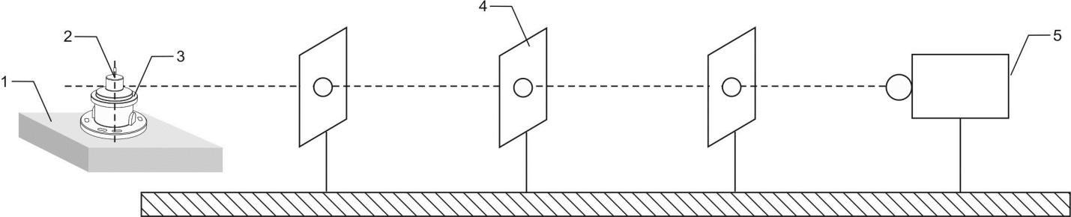

1. *Installation diagram*

Where:

1 is the rotating workbench of distribution photometer.

2 is the photometric center of AtoN lamp.

3 is the AtoN lamp.

4 is the baffle.

5 is the photometer.

For Array AtoN light (AtoN light with 2 or more obvious gap light-emitting areas), when the luminous intensity or luminous intensity distribution is measured with a goniophotometer, each light-emitting area shall be measured separately if the measurement distance in 8.6 can’t be met. The photometer should be aligned with the reference center of each light-emitting area during measurement, and the data of each light-emitting area shall be reported.

## Spectral Correction

Even photometric systems with low *f*1׀ figures can exhibit significant errors at extremes of the visible spectrum. If the light source being measured has a spectral power distribution that is significantly different from the calibrating light source, especially if it has a narrow band of distribution (such as LED sources), spectral correction should be undertaken. For the white light source being measured, although it is strongly recommended, it is not necessary to correct the spectral mismatch error. For the coloured light source being measured (such as red, green and blue monochromatic light), the spectral mismatch error must be corrected.

An accepted method of correction is by use of a spectral correction factor (SCF) [6], as given by:

$$SCF=\frac{\int_{λ}{S_{A}\left(λ\right)S_{rel}\left(λ\right)dλ\int_{λ}{S_{t}\left(λ\right)V\left(λ\right)dλ}}}{\int_{λ}{S_{A}\left(λ\right)V\left(λ\right)dλ\int_{λ}{S_{t}\left(λ\right)S_{rel}\left(λ\right)dλ}}}$$

1. Spectral correction factor

Where:

*St(* is the spectral power distribution of the test lamp, which can be measured by the spectroradiometer described in 5.5 ;

*SA (* is the spectral data of the CIE Illuminant A

*Srel(* is the relative spectral responsivity of the photometer

Using this equation, the correction factor can be obtained for any light source of known spectral power distribution (see A 4.18). If a calibrated light source is being used as a reference, its spectral power distribution *Srel(* may be substituted for *SA (*

The correction factor will have an associated uncertainty derived from the spectral measurement process and the pertinent calibration details of equipment used in the measurement.

A second method of spectral correction is by use of a calibrated light source with the same spectral power distribution as that of the test lamp. Measurement of the calibrated light source will establish a scaling factor that may be used to correct the measured illuminance of the item under test.

If the SCF cannot be obtained, a strict alternative method can be used to obtain the correction factor: a calibrated spectroradiometer and photometer is used to measure the photometric value of the AtoN light respectively in the same position and the same luminous state of the measured light source, then the correction factor is calculated according to Equation 6. The corrected photometric value is obtained by multiplying the measurement value of the photometer by the correction factor. For AtoN lights with two or more colors, photometric correction shall be carried out for each color separately.



1. Correction factor

Where:

 is the photometric value of the AtoN light measured by a calibrated spectroradiometer.

 is the photometric value of the AtoN light measured by a photometer.

 is the correction factor of the photometer.

The correction factor will have an associated uncertainty from the spectroradiometric measurement process and the relevant calibration details of the equipment used in the measurement.

## Reference center

The reference centre of the light source within the DUT is usually based on the centroid of the geometric shape of the luminous area. The reference centre of the DUT itself is then determined taking the following into consideration.

* If the light source is surrounded by an opaque outer shell, then the DUT reference centre is the intersection point with the axis passing through the geometric centre of the light source and the vertical plane of the border between the outer shell and the light emitting surface;
* If the light source is surrounded by an outer shell that diffuses and transmits the light source, then the DUT reference centre is the geometric centre of the light emitting surface (including the diffusing and transmitting outer shell);
* If the light source is surrounded by a transparent outer shell or the light source is exposed, then the DUT reference centre is the geometric centre of the light source;
* The DUT reference centre of a lighting fixture in which multiple light sources emit light within the same light emitting plane is one of the above methods in which the multiple light sources as a whole are used as a single light source;
* For single LEDs or planar arrangements of LEDs the DUT reference centre corresponds to the tip of the lens or top of the emitting surface.

In practical applications, the reference center of a navigation light device can usually be taken as the center of the three-dimensional figure of the outline of the light-emitting surface. For omnidirectional beacon lights, the geometric center of the lens is used as the reference center (in most cases, it is the intersection of the vertical center axis of the beacon light and the horizontal center plane of the lens). For beacon lights with directional light, the center point of the light-exiting surface of the light-emitting surface is used as the reference center.

When it is necessary to carry out more detailed photometric measurements or conduct error and uncertainty research caused by the reference center offset photometric center position, please refer to the content of Annex F.

## Limiting Photometric Distance

Before commencing a measurement, the limiting photometric distance of the item under test should be estimated.

Provided the measuring distance is relatively large compared to the size of the light source (greater than fifteen times as a rule of thumb), this method is simple and accurate for unfocussed light sources. However, when measuring light beam projection apparatus, such as a light source and lens or mirror system, much greater measuring distances are required to ensure an error free result when using this method. At these greater distances several problems arise, such as the effects of atmospheric transmissivity and disturbance, and the difficulty in measuring much lower levels of illuminance. The projection apparatus may be rotated through different angles and illuminance readings taken to determine the shape of the projected beam.

This involves calculating the crossover distance for a projection apparatus such as a marine aid-to-navigation light. John W. T. Walsh described a method for determining crossover distance in his book on Photometry[8], as follows:

$$d=\frac{R^{2}}{4f}+\frac{R}{r}(f+\frac{R^{2}}{4f})$$

1. Crossover distance

Where:

*d* is the crossover distance

*f* is the focal length of optical system

*R* is the radius of the optic aperture

*r* is the radius of the light source

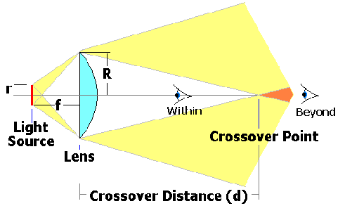

1. Crossover Distance

An approximation of crossover distance can be obtained by the formula:

$$d=2\frac{fR}{r}$$

1. Crossover distance – approximation (1)

The approximation only holds good for an optical lens system with a collection angle of approximately 63°. If the collection angle is markedly different, the full formula, as prescribed by Walsh, should be used.

Equation 22 is good for circular optical apparatus with a spherical light source but when the optical system is larger in one dimension than another; for example, a rectangular lens with a cylindrical light source, the vertical and horizontal crossover distance will be different. In this case, the formula can be expressed as follows:

$$d=2\frac{fH}{h}$$

1. Crossover distance – approximation (2)

Where:

*d* is the crossover distance

*f* is the focal length of the optical system

*H* is the height of the optic aperture

*h* is the height of the light source

or

$$d=2\frac{fW}{w}$$

1. Crossover distance – approximation (3)

Where:

*d* is the crossover distance

*f* is the focal length of the optical system

*H* is the width of the optic aperture

*h* is the width of the light source

Both the crossover distances of height and width should be calculated and the greater of the two used. For an omnidirectional beacon, only the vertical crossover is relevant, therefore only Equation 24 is relevant.

For a precision sector projector, the crossover distance may be expressed as follows [27]:

$$d=2\frac{R}{α}$$

1. Crossover distance – Precision sector projector

Where:

*d* is the crossover distance

*R* is the radius of the optic aperture

*α* is the requested angular resolution

**The minimum photometric distance may be taken as twice the calculated crossover distance.**

In cases where the sizes of optical components are unknown, the minimum photometric distance may be determined by measuring the intensity at several different distances from the beacon, always on the same radial coordinate, and assessing the distance beyond which the resultant measured intensity is consistent [28].

For example, when the AtoN light is in the steady light state, the initial distance between the photometer and the AtoN light is 20 times the diameter of the lens of the measured AtoN light . Then, move the photometer so that the relative distance between the photometer and the reference center of the AtoN light increases by 1 m each time, and measure the luminous intensity at each distance until that the three reading changes (maximum subtract minimum) divided by the last value is less than 0.5%.

In practice this will be restricted to small sealed beacons, whose component parts are not measurable.

## Measurement Aperture and Measurement Angle

The measurement aperture is the physical size of the photoreceptor active surface, i.e. that area receiving light being measured. It is sometimes quoted as an area or, if the aperture is circular, a radius or diameter.

The measurement angle is described by the aperture over the measurement distance and usually refers to a point source of measurement. The measurement angle is important when carrying out goniophotometry, where a graph of intensity against angle is being plotted. The measurement angle describes the integral angle over which each incremented measurement is carried out, and should therefore approximate the goniometer incremented angle.

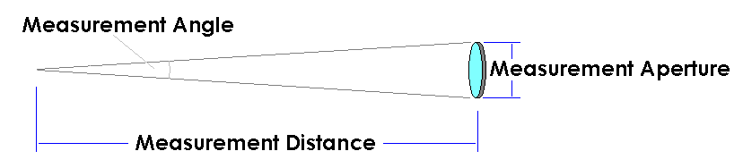

1. Measurement Angle

Providing a<<d, the measurement angle may be calculated as follows:

$$θ=2 x arctan\frac{a}{2d}≈arctan\frac{a}{d}≈\frac{a}{d}(radians)$$

1. Measurement angle (a<<d) (1)

or providing r<<d:

$$θ=2 x arctan\frac{ar}{d}≈arctan\frac{2r}{d}(radians)$$

1. Measurement angle (a<<d) (2)

Where:

$θ$ is the measurement angle

*a* is the diameter of the measurement aperture

*r* is the radius of the measurement aperture

*d* is the measurement distance

## Measurement of Luminous Intensity and its Angular distribution[18]

### General

The measurement of angular dependency, sometimes called the angular distribution, of luminous intensity (see Definitions) is usually carried out by using a goniophotometer. In order to carry out angular measurements using the goniometer it is usually necessary to make the item under test exhibit a fixed light. For rotating beacons, this can be achieved by disabling the rotation mechanism and locking the mechanism in one position. If the item under test emits more than one beam, each beam axis or surface should be identified with the datum clearly defined. Separate vertical and horizontal plots should be carried out for each beam axis.

If the light source within a rotating beacon is non-uniform and the measurement is to be carried out by rotating the whole beacon, including the light source, on the goniometer, additional output data for the bare light source, for example a lamp polar plot, should be obtained. If the measurement is to be carried out with the lamp in a fixed position and not rotated with the goniometer, measurements of all emitted beams should be carried out with the light source in two different positions, those that give maximum and minimum intensity.

For omnidirectional beacons with a flashing light source, the light source should be made to light continuously by following instructions in the manufacturer’s handbook. If no instructions are available, advice from the manufacturer or supplier should be sought. It should be noted that the continuous intensity of a beacon exhibiting a fixed light may be different to the peak intensity of the same beacon when it exhibits a flashing light (see section 10.4)

### Recommended Measuring Planes

The luminous intensity of the navigation light is a function of two angles I = I( $θ$, $ϕ$) (see 5.2 ), and the measurement of the intensity distribution is often reduced to a number of planes. Within these planes the intensity distribution depends on one angle only. For Signal Lights, the recommended planes are horizontal and vertical planes.

#### 'Pencil beams'

The reference axis of the beacon is usually in or near the direction with highest intensity and it should lie at the junction of vertical and horizontal planes. Therefore, the horizontal and vertical planes should include the reference axis (datum). All angles should be referenced to this axis.

#### Horizontal plane



1. Horizontal Plane

#### Vertical plane



1. Vertical Plane

#### 'Fan Beams'

#### Horizontal plane:

In the horizontal plane a reference axis (datum) has to be defined. The selection of this axis is arbitrary because there is no preferred direction for the intensity. All angles are referenced to the axis defined.



1. Horizontal Plane of a Fan Beam

#### Vertical plane



1. Vertical Plane of a Fan Beam

It is recommended to use more than one vertical plane. Each vertical plane is named by its horizontal angle from the horizontal angle from the horizontal reference axis.

For omnidirectional lights with one colour only, at least three planes three equally spaced vertical planes shall be measured, one of which shall include the characteristic vertical plane where the 10% percentile luminous intensity lies.

For lights with coloured sectors measurements should be taken in at least one vertical plane per sector.

### Luminous intensity distribution measurement

#### Measurement of Luminous Intensity Distribution of Pencil Beam

The rotating workbench of the distribution photometer shall carry out rotating scanning in the horizontal direction (as shown in Figure 31 ) and vertical direction (as shown in Figure 32 ) respectively at an angle interval of no more than 0.1 ° from the reference axis, and the scanning range shall not be less than 2 times of the corresponding nominal beam divergence angle. The photometer collects and extracts the photometric signal at each angle. After spectral correction (8.4) the illuminance value ......, ,,,,,,,......, is measured and the luminous intensity at each angle ......, ,,,,,,,........ is calculated according to Equation 19. Draw the horizontal light intensity distribution curve and the vertical light intensity distribution curve respectively, and both the horizontal distribution graph and the vertical distribution graph reach the 1% light intensity point (or the lowest possible reading).

The above minimum requirements for angular resolution apply to all directional and rotating beacon lights and projecting beacon lights .

1. *Horizontally Rotational Scanning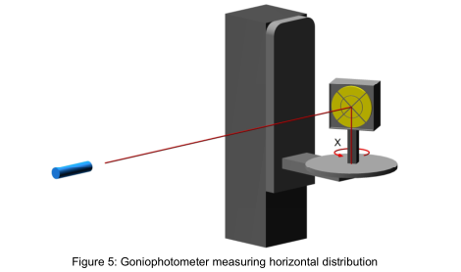*
2. *Vertically Rotational Scanning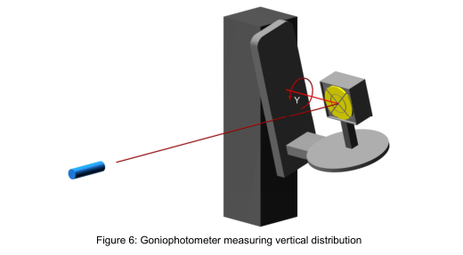*

#### Measurement of Luminous Intensity Distribution of fan Beam

The rotating workbench of the distribution photometer shall carry out rotating scanning on the horizontal datum plane at an angle interval of no more than 1 °, and the scanning range shall not be less than the nominal beam horizontal divergence range of the measured AtoN light. The photometer collects and extracts the photometric signal at each angle. After spectral correction (8.4), the illuminance value ,,,......, is measured and luminous intensity at each angle ,,,......., is calculated according to Equation 19. Draw horizontal luminous intensity distribution profile of fan beam at 360 degree.

The rotating workbench of the distribution photometer shall carry out rotating scanning in the vertical direction at an angle interval of no more than 0.1 °from the reference plane, and the scanning range shall not be less than 2 times of the nominal beam vertical divergence angle of the measured AtoN light. The photometer collects and extracts the photometric signal at each angle and measures the illuminance value ......, ,,,,,,,......after spectral correction (8.4). Luminous intensity at each angle ......, ,,,,,,,....... is calculated according to Equation 19. Draw vertical luminous intensity distribution profile of fan beam to the 1% luminous intensity point (or lowest possible reading).

At least three equally spaced vertical profiles should be recorded, one of which should be recorded at a position on the axis where the intensity approaches the 10th percentile value of the horizontal profile. Additional vertical profiles may be required to adequately study irregularities in the horizontal profiles.

Minimum requirements for angular resolution apply to all omnidirectional lights.

#### **Measurement of luminous intensity distribution of array AtoN light**

For array navigation lights, the luminous intensity values at each angle should be measured for each light-emitting area according to the method in 8.8.3.1 or 8.8.3.2, and the luminous intensity values of each light-emitting area are added according to the corresponding angle to obtain the luminous intensity value at each angle of the entire beacon light. Then dram the luminous intensity distribution curve .

### Measurement of Specification Peak Intensity

#### **Measurement direction**

The measurement direction of specification peak intensity is the direction of reference axis for pencil beam; For fan beam, the direction of any  percentile intensity measured in 8.8.3.2 on the reference plane is taken as the measurement direction of the specification peak intensity. In general, the measurement direction of the specification peak intensity is denoted as (0,0) direction, and the value of the specification peak intensity is denoted as .

#### **Measurement of** Specification Peak Intensity of Steady Light

A conventional photometer is used to perform spectral correction (8.4) and measure the luminous intensity in the (0,0) direction described in 8.8.4.1, and take the average of the three sets of readings to obtain the specification peak Intensity of fixed light, $I_{0}$.

If the AtoN light under measurement is modulated, ensure that the deviation of three readings are within 1%, otherwise a fast photometer is required. A fast photometer is used to perform spectral correction (8.4) and collect the luminous intensity profile versus time for 1s in the direction (0,0) described in 8.8.4.1 to calculate the modulation period of the modulation light, and the average luminous intensity within one or more complete periods is taken as the specification peak Intensity of steady light ,.

#### **Measurement of the effective intensity of the rhythmic light**

A. Direct measurement method

Under the measurement distance that meets the requirements of 8.6, set the navigation light to the rhythmic light state in the (0,0) direction described in 8.8.4.1. After meeting the requirements of 7.5 equipment warm-up stability, use a fast photometer to undergo spectral correction (8.4) and measure the instantaneous intensity versus time profile of each flash individually $I(t)$. The measurement duration is not less than one flash period, and the sampling frequency is not less than 500 Hz. Calculate the effective luminous intensity of the specified rhythmic light $I_{0,eff}$ as described in 10.4 .

1. Conversion measurement method

The AtoN light is set to the fixed light state, and measure the specification peak Intensity of the fixed light $I_{0}$ three times according to the method of 8.8.4.2 . If the deviation of the three readings is greater than 1%, the measurement should be carried out according to 8.8.4.3.a.

Use a fast photometer to collect the fixed light illuminance value at any position $E_{0}$ after spectral correction (8.4) . Set the beacon light to the rhythmic light state. After stabilization, use a fast photometer to measure the curve of the illuminance changing with time at the same position of each flash $E(t)$. The measurement time is not less than one flash period, and the sampling frequency is not less than 500 Hz. If the light modulation frequency of the lamp is higher than 500 Hz, the fast photometer should use a higher frequency for sampling. Use the curve of illuminance versus time $E(t)$ to calculate the effective illuminance value $E_{0,eff}$. as described in 10.4. Calculate the effective luminous intensity, $I_{0,eff}$, of the rhythmic light in the (0,0) direction by equation 29 .



1. *Effective luminous intensity of the reference rhythm light*

Where:

is the effective intensity of the rhythm light in the direction (0,0).

 is the specification peak intensity of fixed light, which is the average value of three measurements.

 is the illuminance of fixed light state at a certain position.

is the effective illuminance in the rhythmic light state at the same position as the measurement of .

1. Estimation measurement method

In some occasions with low requirements, the effective intensity of rhythmic light can be estimated by looking up the table. See Annex B of IALA Guide G1135 [41] for details.

Note: To determine the effective intensity of a flashing omnidirectional aid-to-navigation light operating at a chosen character, the time-dependent luminous intensity profile should be measured. The absolute values of the instantaneous luminous intensity do not have to be measured, if the peak intensity during a flash is equal to the intensity measured when the item under test provides a fixed light. This requires that the time duration of a flash generated by a contact-closure (such as a tungsten-incandescent lamp that is switched on and off) be of sufficient length to ensure that full output of the light source is achieved. Examples of types of illuminant that may exhibit different values of instantaneous peak intensity and continuous intensity are:

1. A tungsten filament lamp whose time to reach full incandescence is greater than the contact-closure time of the device controlling the lamp supply [2].
2. An LED whose luminous intensity reduces with time when supplied with constant current, this being the result of an increase in junction temperature of the LED.

Care should therefore be taken to ensure that such devices either reach full incandescence during the measurement of the flash profile or that the relationship between instantaneous peak intensity and continuous intensity is known. The latter may be treated as an error to which a correction factor is applied with an associated correction uncertainty.

For rotating beacons, the instantaneous luminous intensity may be plotted against time by allowing the beacon to rotate under its own power and recording each beam as it passes the measuring instrument. With this method, the light source does not usually rotate. If the light source is non-uniform, measurements of all emitted beams will be carried out with the light source in two different positions, those that give maximum and minimum intensity.

### Measurement of Specification Peak Intensity of array AtoN light

For array AtoN lights, the specification peak intensity of each area shall be measured according to the method of 8.8.4.2, and the effective intensity of the rhythmic light of each area shall be measured according to the method of 8.8.4.3. The sum of the specification peak intensities of each area is the specification peak intensity of the AtoN lights.

## Measurement of rhythm of Light and flash duration

A photodetector with a sampling frequency not less than 500 Hz can be used to measure the rhythm of light and flash duration. The latter can also be measured with a stopwatch, when the flash duration of the rhythmic light is less than 10 s, it needs to be continuously measured for 20 cycles; and when the flash duration is greater than or equal to 10 s, it needs to be measured continuously for 10 cycles. The time measurement accuracy of the above two measuring devices should not be lower than 0.01 s.

## Detailed Measurement Methods

In addition to these general measurement methods and requirements, two detailed methods, for the photometry of projection apparatus such as aid-to-navigation signal lights, have been reviewed and approved for inclusion in this document: Zero-Length Photometry (ANNEX A) and Outdoor Telephotometry (ANNEX B). Much of the equipment and measurement procedures are the same for all methods. Unique requirements for both methods are discussed in their respective sections.

These detailed methods have been reviewed and accepted as providing equivalent results, within stated uncertainties. Other methods of measurement are not excluded, but should meet the same criteria for traceability and evaluation of uncertainty described in this recommendation.

# COLORIMETRY METHODS AND REQUIREMENTS

## Standard Laboratory Colorimetry

The measurement of the colour of a light source in the laboratory is carried out by one of two methods; either by use of a tristimulus colorimeter (see 5.4.2), or a spectroradiometer (see 5.5.1 and 5.5.2). The results from either method should be reduced to x, y coordinates that enable a colour point to be plotted on a CIE 1931 chromaticity diagram (see section 4.24) [24]. The transmissivity of the atmosphere over short distances in the laboratory may be taken as unity. The light source is usually mounted on an optical bench or table to reduce the uncertainty of distance measurement.

For the light with only one color or the same color, the overall color of the light can be measured at close range or by placing the beacon light in an integrating sphere.

When measuring the overall colour of a light, the measurement may be carried out by placing the beacon in an integrating sphere. However, if the angular dependence of colour is being measured (for example of a sector light), a minimum colorimetric distance should be employed. The crossover distance defined in 8.6 may be used for this purpose.

To ascertain the colour of the light source in more than one direction, the light source may be rotated about its light centre and several measurements carried out at different orientations. To ensure that a light source fully and evenly illuminates the measurement aperture, a diffuser or integrating sphere may be used.

Provided the measuring distance is relatively large compared to the size of the light source (as a rule of thumb greater than fifteen times the greatest dimension of a light source), this method is simple and accurate for bare or unfocussed light sources where the measurement angle is unimportant. However, when measuring light beam projection apparatus, such as a light source and lens or mirror system, the measurement angle may be important and the rule of thumb no longer applies, especially when different coloured sectors are being measured. It is also important when considering the observed colour of a beacon comprising a cluster or array of LED that may exhibit different individual colours. If the measurement angle needs to be small, then either the measurement distance should be increased or the measurement aperture should be decreased. At greater measurement distances, the lower levels of illuminance at the measurement aperture may increase measurement uncertainty considerably due to instrument noise. A goniometer may be employed to facilitate the measurement of colour against angle.

The colour of an LED is therefore likely to change during its operation as the device current warms the junction. This means that there may be a significant difference between an LED exhibiting a rhythmic character with a low duty cycle and one exhibiting a high duty cycle character (e.g. occulting) or continuous light. It is recommended that an average of the colour over the duration of the flash be taken. When the tristimulus colorimeter is used, multiple measurements can be taken within the flash duration to take the average; when the spectroradiometer is used, the integration time can be set as the flash duration, that is, the average color within this time can be obtained.

Further guidance on basic colorimetry can be obtained from CIE publications [14], [24], [30], [33] and [34].

## Alignment

The datum point identified in A 9.2 for photometric measurement should be the same, where possible, for colorimetry. The measurement distance and measurement angle should be reported.

## Measurement System Spectral Response

### Tristimulus colorimeter

Because the measurement process involves a combination of the responses of three filters, spectral mismatch correction is more difficult for tristimulus colorimeters than for photometers. Errors are more likely when measuring light sources with narrow spectral distribution (e.g. LEDs) and when that distribution is concentrated in a less sensitive part of the visible spectrum.

For the selected calibration light source, the relative spectral responsivity of the colorimeter can be expressed in the form of normalized spectral responsivity $s_{i}^{∗}$ ( $λ$), as shown in equation:

$$s_{i}^{∗}(λ)=\frac{\int_{0}^{∞}{S_{λ}·{\overline{t}}_{i}(λ)·dλ}}{\int_{0}^{∞}{S_{λ}·s_{i,r}(λ)·dλ}}s_{i,r}(λ)$$

1. *Normalized Spectral Responsivity of Colorimeter*

Where：

${\overline{t}}_{i}(λ)$ is the color matching function of each channel, i=1, 2, 3 represent the X, Y, Z channels respectively , the same below ;

$s_{i,r}(λ)$ is the relative spectral responsivity,

Note: It consists $s_{x,r}(λ)$ of a long-wave part $s_{xl,r}(λ)$ and a short-wave part $s_{xs,r}(λ)$. According to $s_{x,r}(λ)$ = $s_{xl,r}(λ)$ + ${αs}_{z,r}(λ)$, the latter can be approximated as the part $s_{z,r}(λ)$ of $α$.

$S_{λ}$ is the spectral power distribution of the calibration light source (usually CIE standard illuminant A).

If the spectral power distribution of the measured light source and the calibration light source and the relative spectral responsivity of each output channel are known, the output of each channel can be multiplied by the appropriate spectral mismatch correction factor Fi,TC to correct the output of each channel , the calculation expression of Fi,TC is as follows :

$F_{i,TC}=\frac{\int{{S_{λ,T}\left(λ\right)\overline{t}}_{i}(λ)dλ}}{\int{{S_{λ,C}\left(λ\right)\overline{t}}_{i}(λ)dλ}}$/ $\frac{\int{{S_{λ,T}\left(λ\right)s}_{i,r}(λ)dλ}}{\int{S_{λ,C}\left(λ\right)s_{i,r}(λ)dλ}}$

1. *Spectral Mismatch Correction Factor of Colorimeter*

Where: $S_{λ,T}$ is the spectral power distribution of the measured light source;

$S_{λ,C}$ is the spectral power distribution of the calibration light source;

${\overline{t}}_{i}(λ)$ is the colour-matching function of each channel;

$s_{i,r}(λ)$ is the relative spectral responsivity .

### Spectroradiometer

When using a spectroradiometer to measure for the colorimetric quantities, calibration of the spectroradiometer with a lamp of known SPD is usually carried out before and after each measurement session, especially for mechanical scanning spectroradiometers that are prone to large short-term drifts. Correction of the spectral response of the system is achieved by comparing the data obtained from the measurement of the standard lamp and the data from the standard lamp calibration sheet, see Annex D.2.

## Illumination of the Measurement Aperture

When measuring colour it is important that the light to be measured fully and evenly illuminates the input aperture of the measuring instrument. This can be achieved by inserting a diffuser or integrating sphere between the light source and the measurement aperture. However, such devices can greatly attenuate the light input to the instrument.

## Considerations of Rapid Intensity Fluctuation of the Light Source

As with photometers, the rapid fluctuation of light source radiant intensity can cause measurement errors. The temporal response of the measuring instrument should either be fast enough to follow the fluctuation or should be able to integrate the fluctuation accurately enough to give an average over the required measurement interval.

## Minimum Measurement Distance

With aid-to-navigation beacons, the area of lit beacon seen by the observer should be considered when carrying out colour measurements. With bare or filtered incandescent lamps, the colour changes very little when viewed at different angles. However, this is not necessarily the case with clusters or arrays of LED, where a change of viewing angle will reveal a different group of light sources.

Often, the measurement distance will be limited by the sensitivity of the measuring instrument. Sometimes, optical gain can be employed to increase the light input to the measurement aperture. A ‘zero-length’ measurement system, such as that described in ANNEX B for photometry, may also be used with good effect for colorimetry. However, the use of optical apparatus in the measurement path will introduce spectral distortion and such errors should be corrected. The use of a spectral standard lamp (e.g. measurement by substitution) can help eliminate such errors.

## Measurement Procedure

### Tristimulus colorimeter

The optical axes of the reference standard and the colorimetric probe should be mechanically aligned, both should be connected to a suitable power source, and should reach thermal equilibrium before the measurement begins. The light source under test should also be preheated for an appropriate period of time under the correct operating current or voltage.

To calculate the mean and standard deviation, at least 10 sets of readings shall be recorded for each output channel of the colorimeter.

Take the average value of the corrected tristimulus values X, Y, and Z readings, and calculate the chromaticity coordinates according to equation 16 and 17 in 4.23.

### Spectroradiometer

Stabilize the light source before measurement and pre-illuminate the photoelectric device of the detector to make its performance stable. The wavelength sampling interval should be the same as the spectral width of the instrument, or an integer fraction of it.

The relative spectral power distribution $S_{t}(λ)$ can be obtained by :

$S_{t}(λ)$ = $\frac{R_{t}(λ)}{R_{S}(λ)}$· $S_{s}(λ)$

1. *Relative spectral power distribution*

where:

$S_{s}(λ)$ is the relative spectral power distribution of the standard light source;

$R_{t}(λ)$ is the photodetector reading of the light source to be measured at the wavelength $λ$;

$R_{S}(λ)$ is the photodetector reading of the standard light source at the wavelength $λ$.

According to the calculation equation in 4.22-4.23, the tristimulus value and chromaticity coordinates are calculated with the equal wavelength interval. Generally the measurement for light source color adopts the wavelength interval of 5 nm.

## Detailed Measurement Methods

In addition to these general measurement methods and requirements, two detailed methods, for the colorimetry of projection apparatus such as aid-to-navigation signal lights, have been reviewed and approved for inclusion in this document: Tristimulus Colorimeter (ANNEX D) and Spectroradiometry (ANNEX E).

# PRESENTATION OF RESULTS

A test report should be prepared containing all relevant results annotated to clearly identify the item under test, including the optical assembly and the light source (if separable). The testing procedures (standard laboratory photometry, zero-length photometry, or outdoor telephotometry) should be identified. Test conditions, including voltage settings, current consumption of the item under test and/or the light source (if independently powered) should be listed. Results of measurements of any laboratory test lamp used should be presented with results of the item under test.

Units of the measured results should be as follows:

time seconds (s)

luminous intensity candelas (cd)

angle degrees (°)

luminous range nautical miles (NM)

chromaticity values of x and y according to CIE 1931 diagram

## Luminous Intensity versus Angle

Results of the angular dependence of the luminous intensity should be graphically presented to clearly illustrate the performance of the lantern. Graphs should be linear and annotated to identify causes of irregularities in the intensity measurements, such as shadowing due to filament supports, effects of lens seams, etc. If possible, try to give detailed data in tabular form , such as giving the table of luminous intensity versus angle .

### Main Values of Symmetric/Asymmetric Intensity Distribution

An intensity distribution in a plane, which is symmetric about a reference axis (datum) can be characterised by three values:

reference intensity/maximum intensity I0

full width half maximum: FWHM

full width tenth maximum: FWTM



1. Symmetrical Intensity Distribution

In practice the distributions are not exactly symmetric and there may be minor maxima.



1. Asymmetrical Intensity Distribution

The I0 reported is the intensity at the reference axis. If the maximum intensity Imax in the actual distribution diagram is not on the reference axis, the intensity value and the angle at which it was measured should be clearly stated.

The FWHM values reported should correspond to the angles either side of the reference axis where the intensity first falls to 50% of I0. An overall value of FWHM may be reported in addition but this should be clearly marked ‘overall FWHM’ or ‘overall 50% divergence’.

The FWTM values reported should correspond to the angles either side of the reference axis where the intensity first falls to 10% of I0. An overall value of FWTM may be reported in addition but this should be clearly marked ‘overall FWTM’ or ‘overall 10% divergence’.

For type approval testing, where a symmetrical distribution is specified or expected but measured results show an asymmetrical distribution, the values reported should be characterised by the intensity at reference axis I0, and the reduced overall angles:

FWHM = 2 x min{ΔH1 , ΔH2}

FWTM = 2 x min{ΔT1 , ΔT2}

This is so that the unexpected performance of a beacon is reflected in lower reported values for intensity and divergence angles.

Where:

min{ΔH1 , ΔH2} is the smaller of the two values ΔH1 or ΔH2

### Main values for Omnidirectional Beacons (fan beams)

1. Horizontal Profile

Graphs of the horizontal profiles should be plotted over ±180º from the vertical reference plane or datum. The following main values of the luminous intensity should be reported for the horizontal profile for an omnidirectional light signal, preferably annotated on the graph:

* 1. maximum intensity: Imax
  2. minimum intensity: Imin
  3. mean intensity: Imean
  4. 10th percentile intensity: I10%ile

The 10th percentile value, equalled or exceeded by 90% of the individual measurements of the luminous intensity in the horizontal plane, will be the value used to define the fixed (continuous) intensity of the beacon. See 8.8.3 for angular resolution when measuring for horizontal distribution profiles .

***Note:***

*The luminous intensity of LED light sources under test may vary considerably with LED junction temperature and this can be a consequence of duty cycle of operation, for instance flash character.*

1. Vertical Profiles

Measurements in a minimum of three vertical planes, including and equidistant from the plane where 10th percentile intensity lies, should result in graphs of the vertical profiles plotted between the points where the intensity falls below 1% of maximum. Each graph should preferably be annotated with the main values I0, FWHM and FWTM.

The average of all FWHM and FWTM results, above and below the horizontal reference plane, should then be reported (e.g. -3.1, +4.2 degrees).

For type approval testing, where the profile is expected to be symmetric about the datum, an asymmetric distribution shows deficiency in quality. Therefore, it is recommended to use the reduced overall values for FWHM and FWTM as described in 10.1.1.

### Rotating Beacons (pencil beams)

Graphs of the vertical and horizontal profiles should be plotted between the points where the intensity falls below 1% of maximum. The main values I0, FWHM and FWTM should be reported and preferably annotated on each graph. Based on the horizontal distribution diagram of the luminous intensity of the rotating beacons measured in the non-rotating state (that is, the luminous intensity - angle correspondence) and the rotating rate of the rotating beacons (that is, the angle -time correspondence ), the horizontal angular intensity variation may be converted to a time-dependent luminous intensity profile at specific rotation rates for calculation of the effective intensity and flash duration. For rotating beacons with more than one emitted light beam, the results of all beams will be shown. The beam of least effective intensity shall be used to calculate the nominal range of the beacon.

If the light source within the beacon is non-uniform and the measurement was carried out by rotating the whole beacon, including the light source, on the goniometer table, additional output data for a bare lamp, e.g. a polar plot, should be presented. If the measurement was carried out with a non-uniform lamp in a fixed position and not rotated with the goniometer table, measurement results of all emitted beams will be presented for positions of the light source that give maximum and minimum intensity.

### Directional Beacons

Graphs of the vertical and horizontal profiles should be plotted over the intended arc of utilisation of the beacon or to the horizontal angles where the intensity falls below 1% of maximum, whichever is the greater. Where applicable, the intended arc of utilisation should also be shown on the graph. The main values of I0, FWHM and FWTM should be reported for both horizontal and vertical graphs, and preferably annotated on each graph. The 50% points will be used to define the vertical and horizontal divergences of the beam and should be given as minus and plus angles relative to the vertical reference plane. The 10% points should be shown on the graph but need not be quoted.

## Luminous Intensity versus Time

For aid-to-navigation light signals that are flashed by eclipsing or switching the light source, the instantaneous luminous intensity profile versus time (flash profile) should be plotted with the luminous intensity as the dependent variable (ordinate) and time as the independent variable (abscissa). The plot should be linear and include the entire cycle of the flash character, illustrating both the on and off periods. Secondary plots may be used to illustrate any short-duration fluctuations of the instantaneous luminous intensity.

For rotating beacons where the instantaneous luminous intensity is plotted against time by allowing the beacon to rotate under its own power, plots should be linear and show the luminous intensity profile against time for one complete revolution of the beacon. Secondary plots should also be used to illustrate individual emitted beams in greater detail. If the light source spatial distribution is non-uniform, measurement results of all emitted beams will be presented for positions of the light source that give maximum and minimum intensity. The periods between the times where the intensity falls or rises through 50% of peak intensity (Ipeak) shall be used to determine the rhythmic character of the light.

## Flash Duration

The duration of the measured flash profile should be taken from the point in time when the intensity first exceeds 50% of the peak intensity value to the point in time when the intensity finally falls below 50% of the peak intensity value. The end of a flash should be considered as when the intensity falls below 5% of the peak intensity value for more than 100 ms. In cases where LED lights may have intensity spikes, pulse width modulation (PWM), a convolutional method may be used to determine the flash duration , see Annex G.

## Effective Intensity

The effective intensity of a marine aid-to-navigation light shall be presented in the final results having been calculated using the method outlined in IALA Recommendation E-200-4 on Marine Signal Lights – Part 4 - Determination and Calculation of Effective Intensity, and more guidance on effective intensity can be found in Guideline G1135 [41] . In the case of an omnidirectional beacon, the 10th percentile value of the horizontal plot should be used to scale the calculated effective intensity. It should be noted that a function to calculate a percentile value is available in many computer spreadsheet packages.

Note that some light sources have different intensities for continuous and flashed modes (e.g. LED). Therefore, when the measurement of luminous intensity against angle is carried out with a continuous light source, the intensity measured for a given angle will be different than when the light source is flashing. In this case, intensity against time may be measured in both modes, ensuring the light source reaches stability in each mode, at the same angular reference (e.g. datum). Through the ratio of continuous intensity of the beacon light at the same angular position to flashing (peak or effective) intensity, the effective luminous intensity at the 10th percentile can be calculated correspondingly . The rhythmic character used during the measurement of intensity against time should be reported with the effective intensity value.

When a group of flashes make up a flash character, each flash should be measured one by one, and its effective light intensity should be calculated, the reported effective intensity shall be that of the lowest individual flash effective intensity .

## Spectral Correction

Where the photometric result has been corrected by applying a spectral correction factor, the value of the factor, and how it was applied, should be clearly stated.

## Service Conditions Allowance

Where applicable, a service conditions allowance may be applied to the measured intensity. This allowance accounts for the reduction in intensity through equipment degradation over the lifetime and service period of the equipment when it enters service. The details of such an allowance, and how it was applied, should be clearly reported.

## Light Colour

The measured colour of the light should be reported in x, y coordinates according to the CIE 1931 chromaticity chart (see 4.24). Compliance with the appropriate IALA colour region should also be reported with reference to IALA Recommendation E-200-1 on Marine Signal Lights – Part 1 - Colours. At least three colour measurements should be taken at different points within the arc of utilisation.

If the equipment comprises more than one light source, an LED array for example, there are likely to be variations from one light source to the next. Furthermore, the colour of some types of LEDs, white phosphor-conversion types, in particular, varies with angle of view. It is important for such devices that colour is measured at as many angles as possible within the zone of utilisation. As mentioned in 9.1, the device being measured should be allowed to reach a stable temperature before measurements begin and an average of the colour during the flash duration should be reported.

If all points lie within the recommended boundary, results may be shown as a scatter plot on a chromaticity chart. However, if there are deviations in colour from the recommended regions, a Cartesian plot of x, y chromaticity against angle is preferable because the angles at which deviations occur can be seen.

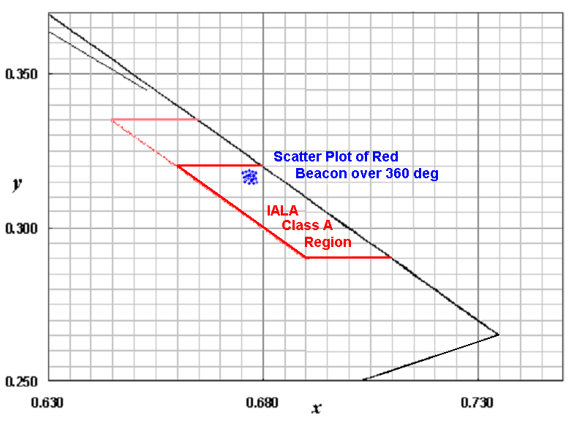

1. Scatter plot of red LED beacon over 360°

## Sector Lights

If the colour of the light emitted by the equipment being tested varies with angle, for example a sector light with white, red and green sectors, the colour should be tested in at least three points within each coloured sector. The results of all measurements should be reported.

If the angle or sector of uncertainty (sometimes called the angle of indecision) at the boundary between two different coloured sectors needs to be defined, colour measurements can be taken at angular intervals across the boundary. The angle of uncertainty is defined as the angle distance from the point the colour departs from the IALA region of the first sector colour to the point the colour enters the IALA region of the second colour. The sector boundary, between the two colours, should be taken as the centre of the angle of uncertainty. The quoted sector arc should be taken between the sector boundaries and the quoted uncertainty given as half the total angle of indecision at each boundary:

e.g. Measured Red Sector Arc -132.5º to -128.2º = 4.3º ±0.4º.

Where the angle of indecision is different for either boundary then these should be reported separately with the most positive angle first:

e.g. Measured Red Sector Arc -132.5º to -128.2º = 4.3º +0.4º/-0.3º.

It is important when measuring colour by angle to ensure that the angular increments are similar to the measurement angle of the instrument (A 9.9); otherwise sharp transitions in colour will be reported incorrectly (see IALA Guideline 1041 on Sector Lights). Figure 36 shows a Cartesian plot of chromaticity x, y coordinates against horizontal angle for a white omnidirectional beacon with a red sector. The vertical yellow line shows where the colour of the light leaves the red IALA Class A region and the vertical blue line shows where it enters the white IALA Class A region. The angle of uncertainty covers 0.8° from -56.6° to -55.8°.



1. Plot of chromaticity across the boundary between red and white sectors



1. As Figure 36 but plotted on a partial CIE 1931 Chromaticity Diagram

The sector information and angle or sector of uncertainty may also be annotated on a plot of intensity against horizontal angle.

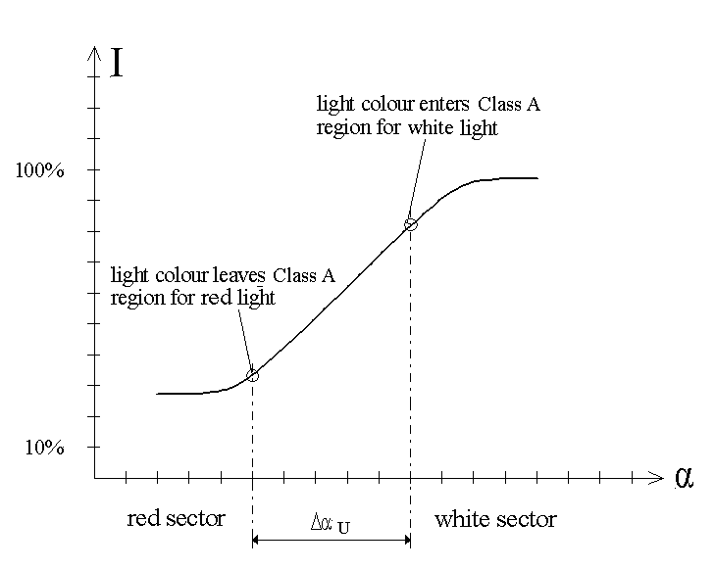

1. Method of Plotting Sector of Uncertainty on Intensity Graph

When carrying out measurements of sector lights it is important to bear in mind the accuracy of alignment of the measurement datum point. If the resolution of the angular measurement is 0.1 degrees, it is necessary for the datum point to be aligned with the measurement instrument to better that half that resolution angle. The angular uncertainty of this datum alignment should be quoted along with the measurement results.

It may be necessary for the horizontal angular information given in the results, i.e. that reported from the goniometer, to be replaced with the bearing from seaward of the intended location of the light. In this case, care should be taken to align the goniometer datum with the cardinal points of the compass and, where possible, to show bearings of landmarks intended for alignment.



1. 360 degree Plot of Sector Light showing Intensity and Chromaticity at 1° Intervals



1. Partial Plot of Sector Light shown in Figure 34 Plotted at 0.1° Intervals

## Spectral Power Distribution

The graph of SPD of a spectroradiometric measurement may be presented. Units of wavelength of the visible spectrum should be plotted on the independent variable (abscissa) and power (either relative or in Watts) should be plotted as the dependent variable (ordinate).

## Nominal Range

The nominal range of a light used as a marine AtoN is the maximum distance at which a light can be seen, as determined by the nominal conditions / in the nominal conditions. The nominal conditions are meteorological visibility 10 NM and the threshold of illuminance on the eye of the observer 2 × 10‐7 lx for night time *nominal* range and 1 × 10‐3 lx for day time *nominal* range.

The nominal range of the lowest resultant effective intensity of all flashes within the rhythmic character or lowest resultant effective intensity of all panels within a rotating optical system should be calculated according to IALA Recommendation E-200-2 on Marine Signal Lights – Part 2 - Calculation, Definition and Notation of Luminous Range and reported.

## Uncertainty & Confidence

The results of all measurements should be presented with a statement of uncertainty and confidence level as outlined in E 9.2 (also see ANNEX H).

# mEASURING IN FIELD APPLICATIONS

## gENERAL

For AtoN lights that have been installed in the specified use positions, carrying out measurement in field application scenarios is an important part of AtoN management. Accuracy and quality of AtoN light are the most basic and important requirement for AtoN lights. The rhythm, period and colour of light are the three major elements of character of AtoN light.

## Key problems

The working environment of the AtoN lights is complex and diverse, the light signal has a large span of luminous intensity, a narrow beam range, and a wide variety of light rhythms. The detection of the character of AtoN light is often subject to the particularity of the rhythm of light and the limitations of detection and analysis technology, especially when the detection is carried out at the scene where the AtoN light works. It is also restricted by many factors such as the detection distance, target stability and background light, etc.. Detection in field applications faces the following four technical difficulties:

### Remote Collection of AtoN Light

The working environment of AtoN lights is complex and diverse, and the detection distance is often unable to be set independently due to environmental conditions. However, the sensitivity of the instrument is limited.

Therefore, for navigation lights with low luminous intensity, being too far away makes it difficult to obtain a strong enough signal. For those with high luminous intensity, being too close can easily cause "blocking" due to excessive signal strength. Both situations make precise measurements equally challenging. It is a significant technical challenge for the same instrument to simultaneously consider completing such a wide range of detection. The detection device needs to possess the capability to adapt to a wide range of luminous intensity measurements.

### Stable Acquisition of AtoN Light

On-site light detection requires ship-based operations at sea. On one hand, due to the influence of wind and waves, floating navigation lights exhibit irregular swaying and fluctuation. On the other hand, ships on the sea unavoidably experience swaying and drifting. Test personnel aboard the ship find it challenging to capture the continuously swaying and fluctuating signals of navigation lights. Therefore, achieving stable signal acquisition poses a significant technical challenge in on-site detection.

### Elimination of the interference of Background Light

During the day, sunlight and various reflective lights are strong. At night, various lights create chaotic background interference for navigation lights. Moreover, the changes in this interference lack a definite pattern. To accurately detect navigation light signals, certain technical means must be employed to eliminate background interference.

### Irregular Rhythm of Light

Navigation lights exhibit a wide variety of rhythmic patterns. They follow specific rules, but there is no uniformity between different rhythms. Rapidly identifying flash duration and the rhythm of light from continuous and irregular flashing signals, and determining their compliance, poses considerable technical difficulty.

## Irregular Rhythm of Light

For the challenging on-site measurement aspects of navigation lights mentioned above, Annex I (Method for Detecting Character of AtoN Light Based on Spectral Analysis ) and Annex J (Detection Method of AtoN Light Based on Image Processing Techniques) provide two methods based on different technological approaches as reference strategies for resolution. Additionally, Annex K presents an on-site measurement method for detecting light source degradation.

# ACRONYMS

AtoN Aid(s) to Navigation

°C degrees Centigrade

CCD charge-coupled devices

CCT correlated colour temperature

cd candela

CIE Commission Internationale de l'Eclairage (International Commission on Illumination)

cm2 square centimetres

DC direct current

fc footcandle

FWTM full-width at tenth maximum

FWHM full-width at half maximum

GUM Guide to the Expression of Uncertainty in Measurement

Hz hertz

IALA International Association of Marine Aids to Navigation and Lighthouse Authorities - AISM

IEC International Electrotechnical Commission

IES Illuminating Engineering Society

ISO International Standardization Organisation

LED Light-Emitting Diode(s)

lm lumen

lx lux

m metre(s)

m2 square metres

MAM Modified Allard Method

ms millisecond

mW milliwatt(s)

nm nanometre

NM nautical mile(s)

RMS root mean square

SCF spectral correction factor

SPD spectral power distribution

sr steradian

W watt(s)

# REFERENCES

1. International Association of Marine Aids to Navigation and Lighthouse Authorities (IALA), Recommendations for the Colours of Light Signals on Aids to Navigation, December 1977.
2. IALA, Recommendations on the Determination of the Luminous Intensity of a Marine Aid-to-Navigation Light, December 1977.
3. Schmidt-Clausen, H.J., Über das Wahrnehmen verschiedenartiger Lichtimpulse bei veränderlichen Umfeldleuchtdichten (Concerning the perception of various light flashes with varying surrounding luminances), Darmstadt Dissertation D17, Darmstadt University of Technology, 1968.
4. Graham, C.H., ed. Vision and Visual Perception, John Wiley & Sons, Inc., New York, 1965.
5. International Commission on Illumination (CIE), Publication No. 18.2, The Basis of Physical Photometry, 1983.
6. CIE Publication No. 69, Methods of Characterising Illuminance Meters and Luminance Meters, 1987.
7. National Institute of Standards and Technology (NIST), Special Publication 250-37, Photometric Calibrations, U.S. Department of Commerce, July 1997.
8. John W. T. Walsh, ‘Photometry,’ Dover Publications, 1965.
9. ISO/IEC Guide 98:1995, Guide to the Expression of Uncertainty in Measurement, 1995.
10. CIE Publication No. 43, Photometry of Floodlights’ (Appendix C.2), 1979.
11. Illuminating Engineering Society (IES), Publication LM-54-1991, ‘IES Guide to Lamp Seasoning, 1991.
12. J. Johnson, Zero-Length Searchlight Photometry System, Illuminating Engineering, Vol 57, No. 3, March 1962, p. 187.
13. IES, Publication LM-11-84, IES Guide for Photometric Testing of Searchlights, July 1984.
14. CIE Publication No. 63, The Spectroradiometric Measurement of Light Sources, 1984.
15. IALA Recommendation E-110 on the Rhythmic Characters of Lights on Aids-to-Navigation, May 1998.
16. CIE Publication No. 86, CIE 1988 2° Spectral Luminous Efficiency Function for Photopic Vision, 1990.
17. CIE Publication No. 127, ‘Measurement of LEDs’ (Technical Report), 1997.
18. CIE Publication No. 70, ‘The Measurement of Absolute Luminous Intensity Distributions’, 1987.
19. CIE Publication No. 121, ‘The Photometry and Goniophotometry of Luminaires’, 1996.
20. ISO/IEC 17025, ‘General Requirements for the Competence of Testing and Calibration Laboratories’,1999.
21. CIE Standard 149-2002 Use of Tungsten Filament Lamps as Secondary Standard Sources.
22. Modified Allard Method for Effective Intensity of Flashing Lights Yoshi Ohno and Dennis Couzin, CIE Symposium 2002.
23. Aerospace Recommended Practice, SAE ARP 5029 Measurement Procedures for Strobe Anti-collision Lights.
24. CIE Publication No. 15, Colorimetry 3rd Edition, 2004.
25. CIE Publication No. 84, Measurement of Luminous Flux,’1989.
26. CIE Publication No. 102, Recommended file format for electronic transfer of luminaire photometric data,1993.
27. German Federal Waterways, Minimum Photometric Distance, 2006-01-31.
28. German Federal Waterways, Determination of Photometric Distance, 2006-01-31.
29. CIE S 014-1/E:2006, CIE Standard Colorimetric Observers
30. CIE S 014-2/E:2006, CIE Standard Illuminants for Colorimetry
31. CIE S 010/E:2004, Photometry - The CIE System of Physical Photometry
32. CIE Publication No. 179, Methods for Characterizing Tristimulus Colorimeters for Measuring the Colour of Light, 2007.
33. CIE Publication No. 53, Methods of characterizing the performance of radiometers and photometers,1982
34. CIE Publication No. 10527(E), Colorimetric observers, 1991 (S002, 1986)
35. CIE Publication No. 17.4, International Lighting Vocabulary, 1987
36. ISO 23539:2005(E)/CIE S 010/E:2004 Photometry -The CIE System of Physical Photometry
37. Compte Rendu 12e session, Vol. 3, p. 37
38. CIE 191:2010 Recommended System for Mesopic Photometry based on Visual Performance
39. CIE 165:2005 CIE 10 Degree Photopic Photometric Observer)
40. IALA R0204(E-200-4) Marine signal lights-determination and calculation of effective intensity
41. IALA G1135 Determination and calculation of effective intensity
42. Couzin,D. 2015. Two triangle flash experiment, TC 2-49 communication, avaliable at http://dx.doi.org/10.6084/m9.figshare.1424488
43. Tutt, I. 2016. Visual perception of non-rectangular flashes at threshold. Report No: RPT-04-IT-AW-16, GLA R&RNAV
44. Couzin,D. 2015. Basis of Allardian le methods_how to fix MAM, TC 2-49 communication，available at http://www.academia.edu/12519872
45. IALA R0201(E-200-1) Marine signal lights-colours
46. IALA G1041 Sector lights
47. IALA R0202(E-200-2) Calculation, defination and notation of luminous range
48. EN 13032-1 Light and lighting-Measurement and presentation of photometric data of lamps and luminaires
49. Optics, Miles V. Klein / Thomas E. Furtak, 1986, Chapter 4.1, Stops and Apertures
50. Optics, Miles V. Klein / Thomas E. Furtak, 1986, Chapter 4.2, Radiometry and Photometry
51. DETAILED MEASUREMENT METHOD - ZERO-LENGTH PHOTOMETRY
52. INTRODUCTION

Zero-Length Photometry is a methodology for approximating far-field conditions in a short distance. The principal technique of Zero-Length Photometry is the use of a paraboloidal mirror to optically place the detector at an infinite distance from the source and thus out of the near field. An incoming plane wave, incident upon a concave paraboloidal mirror is converted to a converging spherical wave. The resulting image is measured by a detector at the focal point of the mirror [12]. The Illuminating Engineering Society (IES) has presented this as an alternative method for photometric measurement of searchlights [13]. Figure 41 illustrates a Zero-Length Photometry system.

The mirror should be able to focus collimated rays from all sections of the mirror face to a spot no greater than the aperture of the photometer, while excluding off-axis rays. The diameter of the mirror should be greater than the largest dimension of the optical components of the item under test. A front-surfaced mirror is recommended to minimize losses. As with a folding mirror, the relative spectral reflectivity of the mirror should be measured and used in the calculation of the spectral mismatch correction factor.

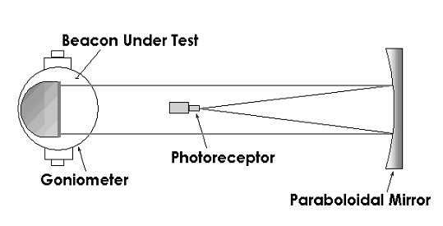

1. Zero-Length Photometry System

The angular resolution depends on the focal length f and the size of the measurement aperture of the photometer head (see Figure 42).

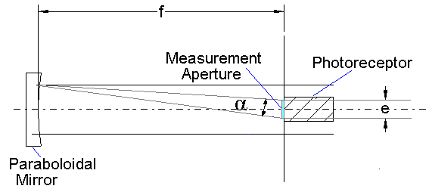

1. Zero-Length Geometry showing Angular Resolution

As an approximation the angular resolution can be expressed as follows:

$$tanα≃ α≈\frac{e}{f}$$

1. Approximation of angular resolution

Where:

$α$ is the measurement angle in radians;

e is the diameter of the measurement aperture;

f is the focal length of the photometer head.

1. OFF-AXIS ZERO-LENGTH PHOTOMETRY

The photoreceptor may be removed from the direct path of the light signal from the item under test by use of an off-axis paraboloidal mirror. This is especially important when measuring smaller optics, where the amount of obscuration may be a substantial proportion of the light signal. Tilting a centred system will achieve the same result, albeit with an increase in measurement uncertainty.



1. Off-Axis Zero-Length Geometry
2. CALIBRATING OR CHARACTERISING THE ZERO-LENGTH SYSTEM

Theoretically, all of the on-axis, collimated rays striking the paraboloidal mirror will be gathered at the focal point of the mirror. Actuality, there will be losses due to the overall spectral reflectivity of the mirror, non-uniformity of the mirror’s reflective coating, and aberrations in the curvature of the mirror. The following method may be used to determine the losses through the zero-length setup. Measure the illuminance from a stable light source at various distances from the photometer. Placing the source in a light box with a variable aperture will allow for generation of a very small source, so that the illuminance may be found to follow the photometric distance law within the limits of the measurement path. Precise alignment of the light box with the detector is required. The lamp current should be monitored and controlled. Make a series of measurements at distances beyond the minimum distance required for the photometric distance law to apply. Determine the intensity of the source and variance from the series of measurements. Move the light box to the goniometer and align with the mirror and the photometer. Monitor and control the lamp current as the illuminance (*Emeas*) is measured through the zero-length system. Using the intensity determined from the direct measurements (*Idirect*), calculate the ‘corrected’ length of the light path.

$$r_{corr}=\sqrt{\frac{I_{direct}}{E_{meas}}}$$

1. ‘Corrected’ length of the light path

*Where:*

*I* direct is the luminous intensity obtained by direct measurement (cd)

*Emeas*is the measured illuminance in Zero-length system (lx)

*Rcorr* is the corrected length of the optical path(m)

The corrected light path length of the zero-length setup, rcorr, is then used to calculate the luminous intensity of the item(s) under test. Determination of the corrected light path length of the zero-length setup should be carried out whenever new data are to be recorded. Changes to the corrected length that cannot be accounted for in the uncertainty budget should be examined to determine if they are caused by some systematic error or equipment malfunction.

The variance recorded during the series of direct measurements of the light box includes the effects of a significant proportion of the elements that comprise the total uncertainty budget of the zero-length photometry setup. The variance may be used as the unexpanded uncertainty for those elements.

1. DETAILED MEASUREMENT METHOD - OUTDOOR TELEPHOTOMETRY
2. INTRODUCTION

Because some aid to navigation lights are projection systems, with minimum photometric distances in excess of 100 metres, all or part of the light range path may be situated outdoors. IALA Recommendations on the Determination of the Luminous Intensity of a Marine Aid-to-Navigation Light, 1977 [2], provides an overall recommendation for this type of measurement. Advantages are that a large building is not required and stray light bouncing off walls will not distort the measurement result. A further advantage is that this method allows for photometric measurements of lighthouses ‘in situ’. Disadvantages of outdoor telephotometry are that ambient light levels, such as daylight, may be high and/or variable and that the state of the weather may affect the light path. The timing of the measurement may therefore be important, and testing may be limited to periods of fine weather or at night.

A further problem with long distance photometric measurements is that the photometer may not be sensitive enough to measure illuminance from a light source several hundred metres away. One solution to this is to use a sensitive photometer receptor (e.g. photomultiplier); another is to use optical magnification (e.g. telephoto lens or telescope) in front of the receptor. At extreme distance both options may be required.

Outdoor measurements may be divided into two types:

1. Those carried out on an outdoor light range, where the item under test is mounted on a goniometer table and its intensity is measured against angular displacement.
2. Those of a lighthouse ‘in situ’ where no goniometer is used, the character of the light is measured against time and shallow prisms are used to obtain a plot of the vertical beam profile.

Just as for standard laboratory photometry, the path length used in outdoor telephotometry should be greater than the crossover distance of the item under test. A flat folding mirror may be used to double the path length of the light range. The photometer should be shielded from stray light emitted by the item under test when folding the light path.

1. ADDITIONAL EQUIPMENT REQUIRED FOR OUTDOOR TELEPHOTOMETRY
   1. Telephotometer

The low values of illuminance that may be incurred when using an outdoor light range may result in the need to couple the photometer to a collecting telescope. The telescope should be capable of collecting light from the item under test and any reference source that might be used. It should also incorporate an iris so that the acceptance angle may be adjusted to exclude unwanted background light. The use of a telescope, or any such device in the optical measurement path, may alter the spectral correction factor, SCF.

* 1. Reference Light

To overcome uncertainties caused by varying atmospheric transmissivity over a longer measurement path, a reference light should be used. This is a light source of known intensity, preferably one calibrated to national standards, with a controlled supply voltage and current.

In practice two measurements are made, one of the item under test and one of the reference light, which is placed in the same (or equivalent) physical position as the item under test. The two readings are then compared. This method does not rely on accurate measurements of distance nor does it require the photometer to be calibrated in absolute units. However, the photometer output should be directly proportional to the illuminance input. Any non-linearity should be accounted for in the uncertainty budget. The measurement path from the reference light to the receptor should, as far as possible, be the same as that from the item under test to the receptor.

1. CALIBRATION PROCEDURES

The use of a reference light as the comparator eliminates the need for absolute calibration of the light measurement system. However, calibration is required of the reference light itself, and the test equipment. The uncertainty in measurements due to the geometric relationships between the reference light, the item under test, and the photometer should also be evaluated and quantified.

1. ATMOSPHERIC CONDITIONS AND AMBIENT LIGHT

One of the greatest uncertainties in outdoor photometry is that caused by changing atmospheric conditions during measurements. Those contributing most to the uncertainty figure are changing visibility and scintillation.

A sizable error may result when visibility varies between the time of measurement of the item under test and the time of measurement of the reference light. If visibility is varying considerably, due to fog or rain, measurements should not be undertaken.

Variation of received light due to scintillation can increase the uncertainty of the resulting intensity figure in the same way as noise. This variation can be reduced by increasing the response time of the photometer or by using some averaging of the photometer output. However, care should be exercised when measuring flashing lights. Increasing the response time of the photometer may cause distortion of the measured flash profile. The response time used should be less than one tenth of the expected duration between the 50% intensity points of the flash. Several measurements should be made and an average of each flash profile can then be calculated.

Variation in ambient light, for instance when the measurement is being undertaken in daylight, can produce an error similar to a zeroing error. Care should be taken to ensure that readings taken from the photometer under ambient light conditions, i.e. with the item under test and reference light switched off, do not vary significantly.

1. RECORDING ENVIRONMENTAL CONDITIONS

A record should be made at the time of the measurement of the following environmental conditions:

1. General weather.
2. Visibility.
3. Temperature.
4. Relative humidity.

These data should be saved with the light range measurement data for the item under test. Visibility meters placed in the optical measurement path can be useful indicators during the hours of darkness.

1. ALIGNING THE TELEPHOTOMETER

Using a viewing sight, or similar apparatus, look into the optical path of the telescope and adjust the telescope alignment and focus until the item under test can be seen clearly in the centre of the eyepiece. The output aperture should then be adjusted so that only the item under test is visible.

The item under test should then be lit and allowed to come to full brightness. When viewed once more through the eyepiece care should be taken to avoid excessive glare to the eye. A filter may be inserted at the eyepiece to facilitate comfortable viewing. The goniometer table should then be turned through the desired angles of measurement to ensure that there is no obscuration of the light emitting surfaces by components in the optical path. When the image is satisfactory in all positions, the optical path output from the telescope should be directed to the photometer receptor.

1. MEASUREMENT PROCEDURES FOR OUTDOOR TELEPHOTOMETRY

Ensure the photometer is switched on and warmed up. The received light from the item under test falling upon the receptor should be measurable on the photometer readout. The gain of the photometer may need adjusting until a satisfactory reading is obtained. To ensure that the reading obtained is caused by received light, the light path can be interrupted and the effect on the reading observed.

The item under test should then be extinguished and the photometer reading observed. If the reading is not zero, due to ambient light, a zero offset may be used to reduce the photometer readout in ambient light conditions. Care should be taken however, when ambient conditions are variable, not to allow the reading to go below zero unless the recording system is suitable.

Complete measurements of the angular and time dependency of the luminous intensity of the item under test, as outlined in 8.4.4.3.

Following measurement of the item under test, mount the reference light on the goniometer table, and ensure that it is in the same position relative to the photometer as was the item under test. Allow the output of the reference light to stabilise, in compliance with the reference lamp calibration data. Take at least two measurements of the luminous intensity of the reference light as soon after the measurement of the item under test as is possible.

The reference light should then be powered down (or baffled, depending on the calibration conditions) and further photometer readings of the ambient light (or ambient plus stray light) recorded. The resultant average value of the reference light minus ambient light (or ambient plus stray light) and associated uncertainties should be calculated and recorded.

A minimum of three complete measurements should be carried to obtain average and uncertainty values.

1. ADDITIONAL EQUIPMENT FOR ‘IN SITU’ MEASUREMENT
   1. Prisms and Prism Frame

For in situ measurements of large optical systems, a lighthouse lantern for example, it may not be feasible to mount the item under test on a goniometer table; nor may it be feasible to tilt the item. In these cases, the vertical beam profile may be measured by placing prismatic sheets on the focal plane of the item under test, to ‘tilt’ the beam by refraction. Two sets of such prisms, each providing 0.5° and 1.5° deviation, enable measurements to be taken over ±2° in 0.5° steps; a total of nine points on the vertical beam plot. A further step at ±3° is possible by the provision of a second set of 1.5° prisms; for a total of 11 points. The relative spectral transmissivity of the prisms, singly and in combination, should be determined and recorded (see Figure 44).

* 1. Reference Projector

For long-range measurements of high intensity beacons, a calibrated, high-intensity reference projector should be used as the reference light. The reference projector should be of comparable intensity, within two orders of magnitude, to the item under test.



1. The use of Prisms to Divert a Beam through a Vertical Angle

1. ADDITIONAL PROCEDURES FOR ‘IN SITU’ MEASUREMENT

In situ measurements are generally conducted on existing lighthouse optics. Because measurement sites using telephotometry should be situated on land, it should be remembered that in situ measurements are usually only feasible in one or two directions within the zone of utilisation of the light. During the measurements, the operational availability of the lighthouse may be affected. Appropriate navigational warnings should be raised.

* 1. Choice of Measurement Site

The first requirement when carrying out a field light measurement is to find a suitable measurement site. This should be a site where stable mounting of the photometric equipment is possible, preferably away from any adverse conditions of weather or unwanted interference from extraneous light sources. The whole of the optic to be measured should be clearly visible from the measurement site.

Calculations of the crossover distance of the optic being measured should be made to establish the minimum photometric distance. Once this minimum is established, a measurement site should be sought which is beyond the minimum photometric distance, and within plus or minus one degree of a line between the optic centre and the horizon. This vertical tolerance of two degrees is approximate and depends on the vertical beam profile of the light to be measured. The closer the measurement site is to the nominal beam centre, the less the measurement uncertainty.

* 1. Setting Up the Telephotometer

The iris of the telephotometer should be set to accept light from the optic being measured and the reference light. The field outside that of interest should be stopped. Daytime is the best time to set up the equipment because the field of view can be easily seen and any potential obstructions accounted for.

* 1. Setting Up the Lighthouse Optic

The lighthouse optic to be measured should be inspected and cleaned. The optic type and dimensions plus any manufacturer’s details should be noted, as should any faults or defects in its operation.

The optic should be outfitted with lamps that conform to design dimensions, rated power consumption, and rated lumen output. The light source should be positioned in the optic in accordance with the procedures established by the optic manufacturer and the Lighthouse Authority.

If the optic is a rotating type, with several light emitting axes, each one should be identified and numbered if not already done so by the manufacturer. This may be done by identifying a unique mark on the rotating part of the item under test (e.g. datum mark or optic door hinge) and numbering each beam or axis from there in the direction opposite to the direction of rotation.

* 1. Setting Up the Prism Frame and Prisms

Install the prism frame between the optic and the measurement site so as to include the maximum area of the lens (or lenses) as possible. Any remaining area of the emitting surface(s) should be screened to prevent light from the optic going past the outside of the frame in the direction of the measurement site (see Figure 44). It should be noted that any blanked area would increase uncertainty of beam profile measurement as upper and lower reflectors/refractors may affect the beam shape.

* 1. Setting Up the Reference Projector

A reference projector should be installed on the outside of the lantern, e.g. on the gallery handrail, as close as possible to the optic and directed towards the measurement site. The path between the reference projector and the measurement site should be free from obstructions.

* 1. Carrying Out the Measurement

Measurements may commence as soon as conditions allow. Bear in mind that zero conditions are those of ambient light, if the ambient light level is varying significantly, e.g. because of clouds passing in front of the sun, measurement uncertainties will be increased. Most field light measurements will need to be carried out at night and in good weather.

On commencement, the reference projector should first be aligned so that its beam centre is directed towards the measurement site. The amount of variation in the reference light reading will give a good indication of the suitability of conditions.

Measurements with different prisms should then be carried out to ascertain the vertical beam profile. Each set of prisms is inserted and the flash profile(s) from the optic recorded. Each measurement set should contain a sample of reference light and ambient light. The range setting on the telephotometer should be recorded.

When all relevant prism positions have been recorded, the prisms, prism frame and screening should be removed. Flashes from the unobstructed optic should then be recorded along with reference light, ambient light and photometer settings. At least three recordings of each flash profile should be taken.

A minimum of three complete measurements should be carried out for each complete character to obtain average and uncertainty values. Dominant measurement uncertainties are likely to be due to variation in light path conditions and reference light alignment. Extreme measurement distance requires a large number of repeated measurements to reduce uncertainty.

1. DETAILED MEASUREMENT METHOD - TRISTIMULUS COLORIMETRY
2. MEASUREMENT GEOMETRY

The standard arrangement for tristimulus colorimetry is exactly the same as for photometry except that the photometric receptor is replaced by a colorimetric receptor.



1. Standard arrangement

For light sources with a narrow intensity distribution the distance between the beacon and the colorimeter has to be increased to ensure the required high uniformity. For the optical input at the receptor, diffusers are necessary so that the light to be measured is spread over the three photodetectors with high uniformity.

To test the correct arrangement the colorimeter should be rotated in the axis. The output should not change during the rotation.



1. Simple Test for Setting Up Colorimeter

Because of the size of the area to be illuminated and the need for high uniformity, the use of a diffuser requires a relatively large measurement distance. However, most tristimulus colorimeters are fairly insensitive and the requirement for a large measurement distance precludes their use for lights with low intensities. To improve the performance of a tristimulus colorimeter, an integrating sphere may be used. The inside of the sphere should be spectrally neutral.

Whatever method is used for obtaining a high uniformity of illuminance at the input to the colorimeter, care must be taken to ensure that any spectral distortion is accounted for.

1. APPLICATION 1

In application 1 a small integrating sphere with an aperture is used.

The light beam that reaches the aperture is measured. The integrating sphere acts as a diffuser for the light. A baffle is necessary to avoid direct light on the colorimeter. A calibration for illuminance and the calculation of luminous intensity is possible (the aperture acts as a photodetector).



1. Beacon outside sphere
2. APPLICATION 2

The second application requires a large integrating sphere and the lantern in test is positioned inside the sphere. The average of all light is used for measurement of the colour functions. A baffle is necessary to avoid direct light on the colorimeter. A calibration for luminous flux is possible.



1. Beacon inside sphere
2. SPECTRUM

The spectral response of each photodetector should approximate the colour matching functions x, y, z. The residual error between the spectral response (xC, yC, zC) and the colour matching functions (x, y, z) should be published in relative values for the range 380 nm to 780 nm in intervals of 10 nm:

$r_{x}=\frac{\frac{−}{x_{c}}−\frac{−}{x}}{\frac{−}{x}}$ $r_{y}=\frac{\frac{−}{y_{c}}−\frac{−}{y}}{\frac{−}{y}}$ $r_{z}=\frac{\frac{−}{z_{c}}−\frac{−}{z}}{\frac{−}{z}}$

1. Spectral response

Where:



$\frac{−}{x_{c}}$, $\frac{−}{y_{c}}$, $\frac{−}{z_{c}}$ is the spectral response of three photodetectors corresponding to x,y, and z respectively;

$\frac{−}{x}$, $\frac{−}{y}$, $\frac{−}{z}$ is the colour-matching function in CIE standard colorimetric system.













The ultraviolet (λ < 380 nm) and infrared (λ > 780 nm) spectrum has to be suppressed to avoid errors.

In general, it can be stated that the error increases when the light is near the infrared or ultraviolet. For many tristimulus colorimeter it is useful to reduce the nominal spectral range when the errors get too high.

1. DETAILED MEASUREMENT METHOD - SPECTRORADIOMETRY
2. MEASUREMENT GEOMETRY

For the optical input, diffusers are necessary so that the light to be measured is spread over the input aperture with high uniformity. For light sources with a narrow intensity distribution the distance between the source and the spectroradiometer has to be adequate to ensure the required uniformity.

To test the correct arrangement the input aperture or the light under test should be rotated in the axis. The spectroradiometer output should not change because of the rotation.

The use of a fibre-optic bundle to couple light from the input aperture to the spectroradiometer is common.

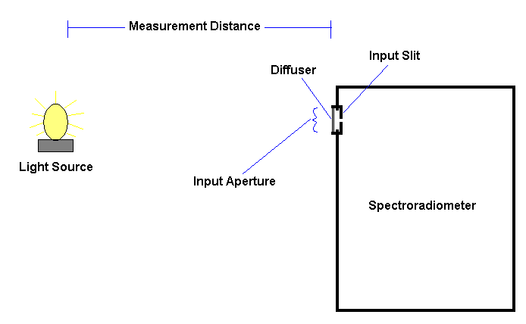

1. Spectroradiometer Measurement Geometry
2. CALIBRATION / CHARACTERISATION

To calibrate or characterise the spectroradiometer system, it is usually necessary to use a spectral radiant flux or irradiance standard lamp. This is a lamp that has been calibrated throughout the spectrum being used usually in milliwatts of power per nanometre of wavelength. The calibration file of such a lamp is usually arranged as two columns of data, wavelength and radiant power (or irradiant power per area). It is important that the resolution of the lamp calibration matches that of the measurement to be taken. Therefore, if a measurement is to be taken of a light source from 380 nm to 780 nm in 10 nm intervals, the standard lamp should also be calibrated over that range at that interval.

The standard lamp should be placed at a distance from the measurement aperture, as specified in the lamp calibration certificate. Power should be applied as specified in the lamp calibration certificate. Then, after allowing the lamp to stabilise, a reading taken with the spectrometer. If a spectroradiometer uses charge-couple devices (CCD array) as the final detector, a note should be made of the integration period over which the spectroradiometer is taking measurements.

Once the results of the measurement are obtained, it should be compared to the similar array of data given in the standard lamp calibration certificate. By dividing the calibration figure at each wavelength with the figure obtained for that wavelength in the measurement, a correction file can be obtained. This correction file can be used to correct measurements of other light sources. If the spectroradiometer uses a CCD array, the calibration factor should include the integration time as a divisor, thereby normalising the value to one second.

1. Example of a Spectroradiometer Correction File

|  |  |  |  |
| --- | --- | --- | --- |
| Wavelength (nm) | Calibration Radiant Flux  (mW/nm) | Measured Radiance  (raw) | Calibration Correction Factor |
| 380 | 2.137801 | 1.3450 | 1.72372119 |
| 390 | 2.789061 | 1.8290 | 1.524910334 |
| 400 | 3.306898 | 1.954 | 2.766352685 |
| ------------- | ------------- | ------------- | ------------- |
| 750 | 28.443800 | 34.5560 | 0.823121889 |
| 760 | 28.814490 | 33.2240 | 0.867279376 |
| 770 | 29.052000 | 31.5550 | 0.920678181 |
| 780 | 29.287460 | 30.3000 | 0.966582838 |

1. CARRYING OUT THE MEASUREMENT

Once the system is calibrated or characterised, the light source under test should be placed at the same distance away from the measurement aperture as the standard lamp. If, due to size constraints, the distance needs to exceed that of the standard lamp, the distance should be recorded and used to factor the measurement results using the inverse square law. However, if the measurement results are only going to be used to determine the colour of the light, no distance factoring is necessary and a relative irradiance will suffice.

The light source under test should then be lit and allowed to stabilise. Once stabilised, a measurement of the spectrum can take place recording the radiant fulx or irradiance at each wavelength. The resultant measurement data can then be corrected using the spectroradiometer correction file. For instrument using a CCD array, normalisation of the integration time to one second should be carried out.

1. RESULTS

It may also be necessary to factor for wavelength if the units quoted in the standard lamp calibration certificate are different to the wavelength interval sampled during the measurement. For instance, if the standard lamp is reported in units of mW/nm, the amount of power in a measurement sample 10nm wide would be ten times that.





1. CONVERTING SPECTRAL DATA TO COLOUR AND CHROMATICITY

The resultant arrays should then each be summed to give three single values of X, Y and Z.

The obtained spectral power distribution (SPD), whether in absolute power or relative power, can be transformed into the tristimulus values X, Y, and Z (see Section 4.22) by integrating the power data array with the standard colour-matching functions of the observer. To convert the X, Y, and Z to conform to the CIE 1931 chromaticity diagram, equation 16 and 17 should be utilized (see Section 4.23).



1. *Laboratory measurement management*

Testing facilities should establish and maintain a quality system appropriate to the type, range and volume of calibration and testing activities it undertakes. All procedures for conducting calibrations and photometric measurements should be documented as part of the quality system.

1. Written Procedures and Documentation

It is recommended that guidelines on laboratory equipment given in ISO 17025 be followed [20].

1. Test Equipment Identification

A list of all test equipment used in the measurement, including model numbers, serial numbers and calibration details, should be included in the test results and any documentation produced from those results.

1. Calibration and Traceability

All test equipment should be calibrated at an accredited test house and the calibration traceable to a national standard. Test equipment should be calibrated at regular intervals and, if calibrated in house, should be calibrated using equipment traceable to national standards. When a replacement calibration certificate is issued, the calibration notes should be checked for any undue variations from the previous calibration. Large changes to calibrated values may affect the uncertainty budget of prior measurements.

All items of test equipment should be uniquely identified. Details of all test equipment should be logged in a register stating manufacturer, model number and serial number. The register should also show calibration due dates for each separate item of test equipment, to ensure that calibration is maintained at correct intervals. Calibration labels, identified with the calibration certificate serial number, equipment serial number and next due date of calibration, should be firmly fixed to the test equipment by the test house upon completion of calibration. Any obsolete calibration labels should be removed from the test equipment by the test house.

1. Identification of Test Items

Each item under test should be described and uniquely identified. If there is no manufacturer’s label, or if the label contains insufficient information to enable the item to be identified uniquely, a label should be attached giving a unique identification for test purposes. The information given on the label should be included in the test results and any documentation produced from those results.

1. Source/Data Identification

The ‘raw’ or ‘source’ measurement data should be clearly identified and stored in accordance with [20]. The use of this data in any subsequent report or test sheet should be made fully auditable, so that the original measurement data can be referred to without ambiguity.

1. Power Monitoring of Item under Test

The power consumption of the item under test should be measured and recorded at the time of the photometric measurement. For electrical systems, power monitoring should be conducted throughout the measurement process.

1. Recording System

All relevant measurement information should be recorded. The recording medium may be manually operated pen and paper, automatic chart plotter or electronic storage such as a computer. The recording system in use should have a response time fast enough to faithfully record all relevant data output from the measuring system.

1. Software

Details of all software used in any measurement process should be recorded. Custom software used in data acquisition, analysis, and/or presentation of results should be documented, and a printed copy maintained with other test procedure documentation. Algorithms used to manipulate data should be documented.

1. Errors, Uncertainty and Confidence

An expression of the result of a measurement is incomplete unless it includes a statement of the associated uncertainty. The results of all measurements should state the range, within which the measured value is estimated to lie, for a stated level of confidence. All type A and type B uncertainties associated with the measurement process should be evaluated in accordance with ISO/IEC Guide 98:1995, ‘Guide to the Expression of Uncertainty in Measurement’ (GUM) [9]. A suitable uncertainty budget should be produced for each measurement process undertaken.

Type A evaluation of uncertainty is made by statistical analysis of a series of observations. Type B evaluation of uncertainty is made by means other than the statistical analysis of the observations; for example, the uncertainty quoted on the calibration certificate of an item of test equipment.

* 1. Systematic Errors (Characterisation)

Any fixed errors within the measuring system should be evaluated and, where possible, corrected by the use of an appropriate correction factor. These errors and corrections should be recorded but not necessarily given with the measurement results. Appropriate uncertainty and confidence figures associated with error correction should be included in the uncertainty budget.

* 1. Combined Standard Uncertainty

The combined standard uncertainty is calculated by combining the individual uncertainties that comprise the uncertainty budget using the square root of the sum of the squares of the individual uncertainties.

* 1. Expanded Uncertainty

The expanded uncertainty is obtained by multiplying the combined standard uncertainty by a coverage factor, k. Unless otherwise determined, it may be assumed that the probability distribution of a measurement result and the combined standard uncertainty is approximately normal. The combined standard uncertainty is equivalent to the standard deviation of the Gaussian distribution. An appropriate coverage factor should be determined in order to provide a confidence level of 95%.

* 1. Sampling Guidelines

Sampling consists of taking enough measurements for a given condition to minimize the impact of minor random fluctuations in the measurement process. A coverage factor between 2 and 3 should be achieved, consistent with the evaluation of uncertainty figures and confidence levels [9]. Sampling procedures should be documented as part of the standard laboratory procedures. Exceptions to standard sampling procedures should be discussed in any test results

1. Analysis and reference of error factors in goniophotometry
2. Measurement precision and Error Analysis
   1. General

The luminous intensity is not measured directly, but is calculated according to the photometric distance law 𝐼 =E∗ $R^{2}$. The calculation of error propagation is usually done by adding the relative errors of each influence parameter (see European Standard EN 13032-1 [48]).

The precision of the illuminance E depends on the photometer and should be found in the photometer datasheet. The preferred values are listed in EN 13032-1 and give a total error $f_{E}$ = $f_{sum}$ for the relative precision of the measured illuminance.

However, the influence of the distance shown by a calculation of the error propagation. Additionally, the distance R often is ambiguous. The relative error of the distance measurement has double influence on the intensity measurement compared with the relative illuminance error.

$$\frac{ΔI}{I}=f_{E}+2∗\frac{ΔR}{R}$$

1. Relative error of luminous intensity

As shown in the paper 'Minimum Photometric Distance' [27], the required distance R is linked to the required angular sensitivity of distribution measurement. The need to measure the angular distribution with a very small resolution of about 0.1° or even less, leads to large distances.

A second aspect, which has to be considered especially for marine signal lights, is the use of sophisticated optical devices (e. g. projectors, drum lenses). For these luminaires the reference position for light emission is not the light source and the precision of R depends on an estimation for a light emission reference or datum. The same will be true for the angles X and Y. The rotation of the luminaire may cause that the reference position for light emission, which should be centered at the photometry axis, draws aside and produces an error ∆X or ∆Y.

The uncertainty for finding the reference position of light emission induces two errors on luminous intensity measurement: error in estimating the photometric distance, and error in estimating the distribution angles.

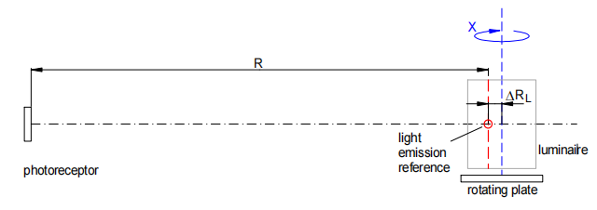

1. Unknown luminaire on a goniophotometer

When the luminaire is set on the rotating plate of a goniophotometer, the light emission reference may not exactly match the rotating axis, but is an offset ∆RL apart. The reference plane of the photoreceptor is defined by calibration very precisely and can be ignored. The distance measurement device will have a relative precision , then the overall uncertainty of the distance will be： $\frac{∆Rtotal }{R}$ =𝑓R+

However, when the luminaire is rotated by the goniometer, some systematic errors are added. This can be shown by triangle calculation (Figure51 ).

1: centre of rotation

2: light emission reference

3: photoreceptor

L: distance photoreceptor- light emission reference

R: distance photoreceptor-centre of rotation

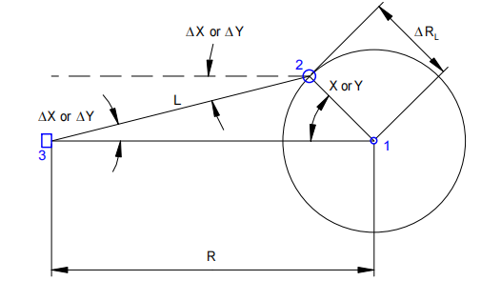

1. Evasion of a non-centered light emission reference on a goniometer
   1. Distance

From cosine rule (for X angle, Figure 51):

L2 =R2+∆RL2 −2∗R∗∆RL∗cosX

1. *Distance relation in goniometer*

Both the angle and the distance error depend on the rotating angle used to estimate the small systematic error only, it is acceptable to make some simplifications.

The distance between photoreceptor and light emission reference varies between L=R−∆RL for X=0° and L= $\sqrt{R^{2} + ∆R_{L}^{2}}$ <R+∆RL for X=90°.

For simplicity, the distance ∆RL between the light emission reference and the centre of rotation is a useful estimation for the absolute error.

Remarks:

— It can be assumed that, when the light emission reference is rotated by an angle larger than 90°, it will not produce light on the photoreceptor.

—When a drum lens is rotated in the horizon (X) the photometry axis and does not move with the lens.

* 1. Angle

From sine rule (for X angle, Figure 51):

$$\frac{sin∆X}{∆RL}=\frac{\sin{X}}{L}$$

1. *Angle relationship in goniometer*

The systematic error ∆X for the angle depends on the rotation angle X.

∆X= sin–1(∗ sinX)

1. *Angle error in goniometer*

For a rough estimation of the error ∆X it can be assumed that L≈R. The systematic error is then:

∆X= sin–1(∗ sinX)

1. Estimation *of angular error* ∆X *in goniometer*

The same discussion is valid for the vertical angle Y and the result is:

∆Y= sin–1(∗ sinY)

1. *Estimation of angular error* ∆ Y *in goniometer*
2. Distance reference
   1. Infinite distance

From geometry, the required measurement distance should be as large as possible. In order to keep the relative error as small as possible, this is usually done by increasing the measurement distance. The mathematical ideal is an infinite distance. In practice the costs for a large photometric chamber and the loss of sensitivity in measuring the illuminance have to be taken into account.

* 1. Photometer reference

There are two main types of photoreceptor: optical window type and diffusion disc type.

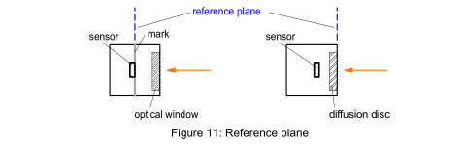

1. Reference plane

For the optical window type, the light enters the sensor through an optical window, which leaves the light nearly unchanged (Figure 52, left). The reference plane is usually the surface of the sensor and is marked on the housing of the sensor (e. g. white ring). In the diffusion disc type luxmeter the light is scattered in the diffusion disc, which makes the measurement more robust for small angle errors. The calibration is done with the outer surface of

the diffusion disc as the reference plane (Figure 52, right). In both cases the reference plane to measure the photometric distance has a precision of about 1 mm.

* 1. Luminaire Reference
     1. **Theoretical Background**

Marine Signal Lights consist of a variety of different optics. Looking at the precision of luminous intensity measurement, there is a strong dependency on the type of optic and its geometry. The theory behind can be found in 'Optics, Klein / Furtak' [49][50].

* + 1. **Paraxial Optics**

The influence of the optic on the reference plane for photometry can be explained with a simple paraxial model. 'Paraxial' means that only the light rays near the optical axis are considered. For signal lights, the optic is used to collect the emitted light rays of a light source into a narrow beam of light to increase the luminous intensity.

The most simple device is a spherical converging lens (Figure 53). On the right side the light source emits light. Some light rays are collected and refracted by the lens to produce a narrow beam on the left side.

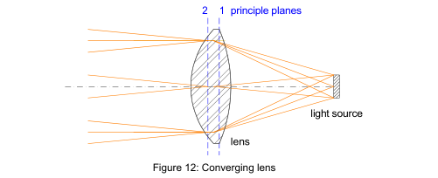

1. Converging lens

The paraxial theory says that for an observer on the left side, the reference plane to describe light emittance is the second principle plane of the lens (both principle planes are shown in Figure 12). This means that the light seems to be emitted from this plane. Usually the plane is located inside the lens and is nearby the lens aperture (for some optical instruments, they may be outside the lens).

To measure the luminous intensity distribution for the converging lens, it is necessary to adjust the second principal plane of the lens into the rotating axis of the goniometer and measure the photometric distance 𝑅 from principal plane to the photoreceptor (Figure 54).

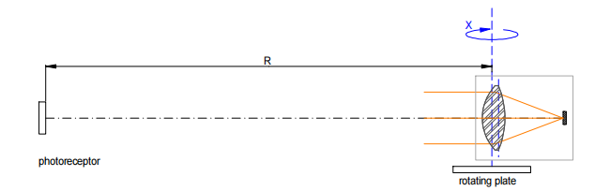

1. Setup of converging lens on goniometer
   * 1. Large Optics

For marine signal lights, the lenses usually have a large diameter, so that a simple definition of the principal planes is not given. The principal plane may even become an elliptical, parabolic or hyperbolic surface. This will produce a systematic error on the estimation of the reference position for light emission and in consequence for the photometric distance.

In many situations it can be assumed that the reference position of light emission is inside the lens. This results in a systematic error ∆RL  for the location of the principal plane, which is the thickness of the lens (example with fresnel lens: Figure 55).

1. 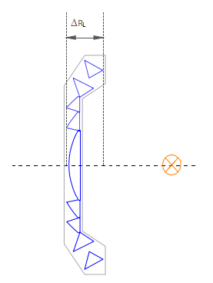Pencil beam fresnel lens
2. Reference for different types of AtoN lights

For pencil Beam Lights , the measurement is done in the horizontal plane and in one vertical plane. Both should intersect in the luminaire axis, which points to the direction of maximum intensity. The centre of rotation is set to the second principal plane of the lens. If the principal plane is not specified by the manufacturer, it can be set to the outer vertex of the lens. As a rough estimation for the systematic error ∆RL  of the light emission reference the thickness of the lens including an optional diffusion disc can be chosen.

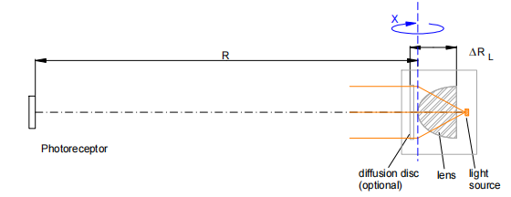

1. Pencil beam light

A simple omnidirectional light is used for buoy lanterns or low range lights. It may be represented by a drum lens with a single light source or a 'radial drum LED layout' . The centre of the light is set to the centre of rotation. Although the main amount of light measured will be from the LED pointing directly to the photoreceptor, there will be some light from the marginal rays. So the systematic error ∆RL will be about half the diameter of the LED arrangement.

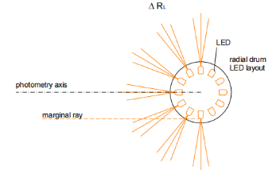

1. Plan view at a 'radial drum LED layout' luminaire

The classical drum lens is typically used in lighthouses. It has a single light source or an equivalent LED module. The horizontal distribution may contain the entire horizon or be limited to a sector. With the use of filters the drum lens can show different coloured sectors. The systematic error ∆RL will be half the diameter of the lens.

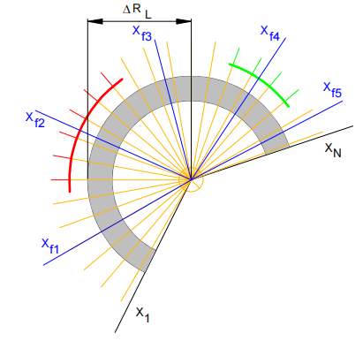

1. Classical drum lens with filters, plan view

A projector sector light has two optical components: projection and condensor lens. The light emission reference is at the projection lens and therefor the centre of rotation should be placed there. The thickness of the projection lens is an acceptable estimation for the systematic error ∆RL .

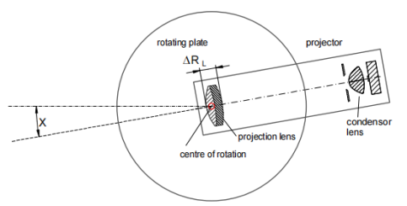

1. Projector set on the goniometer, plan view

Care should be taken, when measuring a fixed arrangement of several projectors. Normally the central projector is in the centre of rotation, so that the outer projectors produce an additional systematic error ∆A (Figure 60). This error has to be considered when calculating the overall error for the distance and the angle.

An alternative is to measure each projector individually and shift the 'active' projector into the centre of rotation (Figure 61). The horizontal luminous intensity distribution will be the sum of the individual measurements. As long as the sectors do not overlap, the vertical distribution for a single horizontal angle is the distribution measured for the related projector.

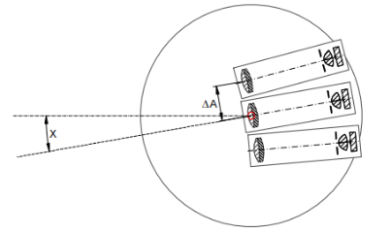

1. Measuring an arrangement of projectors

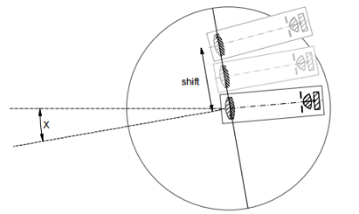

1. Shifting the active projector to the centre of rotation
2. Implementation of the Convolution Function to Determine Flash Duration

The IALA method of determining the flash duration (R0203) has been as follows:

“The duration of the measured flash profile should be taken from the point in time when the intensity first exceeds 50% of the peak intensity value to the point in time when the intensity finally falls below 50% of the peak intensity value. The end of a flash should be considered as when the intensity falls below 5% of the peak intensity value for more than 100ms.”

The method of directly using photometric measurement of flash to determine flash duration cannot take into account the human visual system's perception mode of light. In the case of LED lights that may have intensity spikes and pulse width modulation (PWM), the resulting flash duration may not be accurate.

Using MAM and the improved impulse response function model mentioned above (see 5.7), the effective luminous intensity can be calculated as the peak intensity of the flash, and the duration of 50% peak value is the flash duration after taking into account the pulse response of the human visual system to the flash.

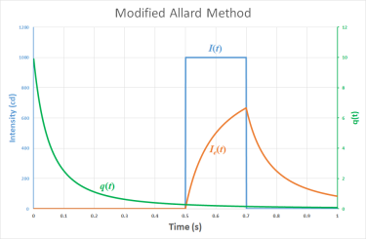

1. Typical application of the MAM. The flash (blue) is convolved with the visual impulse response function (green) to produce the perceived flash (orange).

The results of studies using the aforementioned convolution method to calculate flash durations have shown that, in the vast majority of cases, the theoretical observed flash length is longer than that of the photometric flash length. Also, because of the filtering effect, any sharp spikes in the photometric data are smoothed out. The difference in the photometric flash length and the convolution flash length can vary significantly for complex flash shapes. For some flash shapes, the differences between the flash duration results obtained using the modified impulse function response model and the photometric method are less than those of the MAM method.

One should note that the results presented in this annex are entirely theoretical and have not been tested through observation to understand the after-image effect that the convolution function predicts in its results (i.e. the falling edge of the convolution function gradually fades after the flash has ended, implying that light is “observed” after the flash has extinguished).

1. EXAMPLE OF A PHOTOMETRY UNCERTAINTY BUDGET
2. INTRODUCTION

This example of an uncertainty budget is meant for guidance only. It has been compiled in accordance with ISO Guide No. 2 [9] and incorporates current methodologies. The model used is a simple one incorporating those inputs thought to have a significant effect on uncertainty. The model may change depending on the measurement method, measurement equipment or item being measured. For instance, if the same method and equipment shown in the example were used to measure a beacon with a tungsten filament lamp with a similar spectral output to that of the reference lamp, no spectral correction would be necessary. Furthermore, it can be seen from the uncertainty contributions shown in the example that the uncertainty of photometer gain has little influence on uncertainty and could possibly be excluded from the budget.

A separate uncertainty budget for each individual measurement process should be compiled if there is insufficient knowledge of the uncertainty of the result. For example, the spectroradiometer plot shown in the test report would have its own uncertainty budget for the evaluation of the spectral correction factor (SCF). This would include, as the model, the equation for determining SCF.

In general, if there is any doubt as to the significance of an uncertainty contribution, it should be evaluated, used if necessary or discarded if insignificant. A reduction in uncertainty should always be strived for and unnecessary sources of uncertainty should, wherever possible, be eliminated. Significant types of uncertainty and other limiting factors for two measurement methods are as follows:

1. OUTDOOR PHOTOMETRY
   1. Uncertainties
2. Establishing and measuring beyond the minimum photometric distance.
3. Stray and ambient light.
4. Photometer calibration.
5. Colour correction of photometer for red and green colours.
6. Environmental conditions.
   1. Limiting factors
7. Finding suitable dark real estate.
8. Obtaining sufficient meter sensitivity at the minimum photometric distance.
9. ZERO-LENGTH PHOTOMETRY
   1. Uncertainties
10. Shape, accuracy and reflectance of parabolic mirror.
11. Alignment and calibration of system.
12. Stray and ambient light.
13. Photometer calibration.
14. Colour correction of photometer (plus mirror) for red and green colours.
    1. Limiting factors
15. Cost and accuracy of parabolic mirror.
16. Size of specimen optic is limited to size of mirror.
17. EXAMPLE OF A PHOTOMETRY UNCERTAINTY BUDGET









1. Method for Detecting Character of AtoN Light Based on Spectral Analysis
2. General

Spectral analysis technology can be used to solve the technical difficulties in the quality detection of AtoN lights.

* 1. Remote Collection of AtoN Light

Spectral analysis technology can be used to solve the technical difficulties in the quality detection of AtoN lights.

The optical telescope based on spectral collection technology can be used for remote collection of AtoN light. In the design and selection of a telescope, high resolution, small aberration, strong light collection ability and portability are required.

* 1. AtoN Light Stabilization

The core of stably obtaining light is to effectively deal with swaying. The focus adjustment technology can be used to solve the swaying problem, and the hydraulic head with this technology is an effective means. Placing the signal collection telescope on the hydraulic pan/tilt can smoothly adjust the direction in three-dimensional space, counteract the effect of swing, and track and collect signals accurately.

In addition, it is not easy to timely and accurately collect the beacon light signal through the telescope to directly observe the image formed by the AtoN light. For this reason, beam splitting technology can be used to obtain a small part of the light signal collected by the telescope. Then you can use the electronic eyepiece or other methods to directly watch the image formed by the beacon light through the display screen of the notebook computer, which is convenient for the inspection personnel to observe, and adjust the observation angle in time to accurately collect and obtain the light signal of the AtoN.

* 1. **Elimination of background light interference**

Spectral analysis technology is used to perform spectral analysis on the obtained optical signal, and the light spectrum of the navigation mark is accurately extracted according to the specific wavelength of the light signal of the AtoN. Generally, a spectrometer is used for spectral analysis. The spectrometer used needs to have a reasonable optical path to reduce the optical imaging chromatic aberration and improve the sensitivity of the optical signal detection system. Special attention needs to be paid to the grating constant, diffraction efficiency, wavelength calibration, order overlap interference correction, CCD detectors and other key technical points.

The software is combined with a mathematical model to fit the changing trend of the background light data, and a certain threshold can be set to accurately distinguish the AtoN light signal from the background signal . The recognition of the light character can be solved by the background extraction algorithm, but for some environments with strong background light interference, the character of the beacon light may not be accurately identified. In order to improve the adaptability of the light character recognition algorithm, the method of processing data using local signals can be employed to identify the character of navigation lights. This involves selecting beacon light signals within a certain range where background light interference is minimal.

* 1. Identification of Rhythm and period of Light

For irregular flashing rhythms and periods, establish a database of light characteristics and thoroughly analyze their compositional traits. Summarize the temporal characteristics of light, including the uniqueness of a few specific light patterns as well as features common to all light patterns. For instance, light patterns with a visible duration greater than 7 seconds can be matched with unique light characteristics. The longest duration of darkness within each light pattern is always at the end. Finally, employ specific algorithms in software processing to recognize light rhythms and periods. In general, the algorithmic processing sequence involves: firstly, determining the flashing duration; secondly, identifying the flashing rhythm; and lastly, determining the type of light pattern.

1. Detecting system

The intelligent detection system for the character of navigation lights based on spectral analysis technology can be built as shown in Figure 63 .

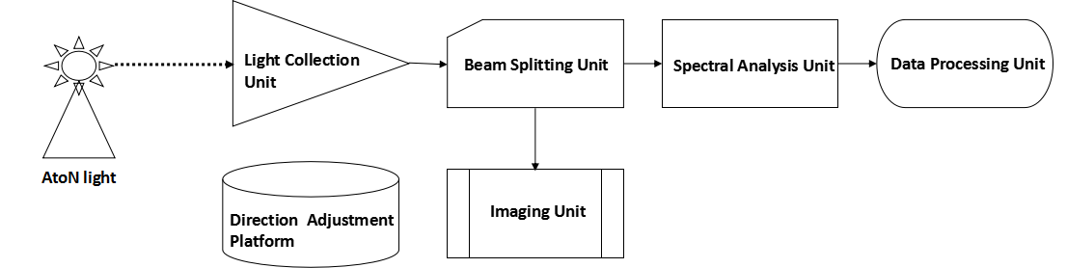

1. Diagram of detecting system

The entire system is mainly composed of a light collection unit, a direction adjustment platform, a beam splitting unit, an imaging unit, a spectral analysis unit, and a data processing unit. The navigational light is collected by the light collection unit, and a small portion is directed to the observation unit through the beam splitting unit, while the majority of the light is transmitted to the spectral analysis unit for spectral analysis. The spectral analysis unit dissects the detected light signals according to their wavelengths and performs photoelectric conversion on the light signals of all wavelengths. The data processing unit analyzes and computes the electrical signals from the spectral analysis unit, detecting the color, flashing rhythm, and period of the light signals. Inspection personnel observe the detection process through the imaging unit, controlling the light collection unit to acquire the light signals in the best way possible to ensure accurate detection. The direction adjustment platform can be freely adjusted in three dimensions. When detecting moving targets, the platform needs to be activated to track the light signals from the tested navigational light.

1. Key **technical points of the system**
   1. Light Signal Collection

The design and selection of telescopes affect the performance of light character detection. If the telescope's aberrations are too significant, the image clarity will deteriorate, leading to a weakening of the optical signal entering the optical system. Therefore, it's necessary to design or choose telescopic systems with lower aberrations. Simultaneously, the portability of the detection instrument and telemetry distance should be considered. A Kepler telescope system with a simple structure, easy adjustment, and high imaging quality is chosen to collect navigation light signals. Additionally, for close-range navigation light character detection in the laboratory or field, a small coupling mirror can be designed.

* 1. Spectral Analysis

One of the key technologies in this system is the design of a reasonable optical path to reduce chromatic aberration in optical imaging and enhance the sensitivity of the light signal detection system. Based on the cross-dispersed Czerny-Turner structure, the system consists of an incident optical fiber, slit, collimating mirror, plane grating, imaging mirror, second-order diffracted light spectral filter, and linear array CCD detector.

Light from the optical fiber output passes through the incident slit and falls onto the collimating mirror, which reflects to form parallel light. The parallel light then undergoes wavelength dispersion by the grating and is finally focused onto the CCD image plane through the imaging mirror, achieving the photoelectric conversion of the signal.

* + 1. Grating Selection

The grating, as a dispersive element, not only determines the operational wavelength range of the detection instrument's spectroscopic system but also directly impacts the spectral resolution of the instrument. Suitable grating constants should be chosen based on the operational wavelength range of the instrument and the desired spectral resolution.

* + 1. Wavelength Calibration

Since this detection instrument is based on spectral analysis technology, it needs to efficiently disperse and image the incident light and accurately determine the corresponding wavelength values of the signals. Therefore, wavelength calibration is a necessary step in this system.

* + 1. Order Overlap Interference Correction

Spectral lines from different diffraction orders can overlap, leading to the appearance of secondary spectral lines that shouldn't exist and affecting the determination of navigation light color wavelengths.

Order overlap interference is an inherent characteristic of diffraction gratings. Although the main diffraction efficiency is concentrated in the 0th and +1st orders, higher-order diffracted light cannot be ignored for high-brightness blue-violet light in maritime environments, leading to overlap between multiple orders of diffracted light. The solution is to restrict short-wave signals from entering the optical system, which can be achieved by placing a long-pass filter in front of the spectrometer to mitigate order overlap interference.

* + 1. Detector Selection

For spectral analysis, the size of a detector's (CCD) individual pixel is an important parameter. If the CCD pixel width is too large, it might lead to undersampling, where the optical system's high resolution cannot be effectively captured by the detector. A smaller pixel width ensures better spectral resolution, but excessively small pixel width could result in decreased CCD sensitivity. Thus, when selecting a CCD, sensitivity and the optical detection system's resolution need to be considered simultaneously.

* 1. Data Processing

The detection system establishes a light character database and designs a sophisticated algorithm for automatic light character recognition. Various algorithm strategies such as grouping alignment, tolerance mechanisms, and temporal exclusion can be employed.

Moreover, algorithms need to be designed to eliminate the effects of background light, such as sunlight during the day, reflections from the sea surface, and reflections from other objects, on navigation light signals. Simulating the trend of background light signal changes and setting a certain threshold can accurately differentiate navigation light signals from background signals.

The character of most navigation light can be recognized using background extraction algorithms. If accurate recognition is still not possible, to enhance the adaptability of the light character recognition algorithm, a method involving data processing of localized signals can be used. This involves selecting navigation light signals within a specific range for character recognition of the light.

1. Technical Requirements

To accomplish accurate and reliable character detection of navigation light, the detection system must mainly fulfill the following technical requirements:

1) Light Collection Unit

For laboratory testing, a regular light-collecting mirror is sufficient to gather light signals into the optical transmission fiber. For field testing, a telescope must be used with a magnification not less than 20X, a focal ratio not exceeding f5.7, and an objective aperture not less than 70 mm.

2) Beam Splitting Unit

The beam splitting unit should only direct a small amount of light for observation during the detection process, with the majority of light signals being transmitted to the spectrometer for detection and analysis. The recommended transmission-to-reflection ratio for the beam splitting unit should not be lower than 70/30.

3) Spectral Analysis Unit

Based on the range of navigation light colors, the spectral coverage range of the spectral analysis unit should not be less than 380 nm to 780 nm. The spectral resolution should be higher than 2 nm, and the sampling speed should not be lower than 100 frames per second.

4) Sampling Frequency

To ensure accurate detection of rapidly flashing navigation light signals, the detection sampling frequency should not be less than 100 Hz.

5) Measurement Duration

In order to ensure the complete detection of at least two flash periods for all light character and accurate detection of the navigation light signals with long flash duration, the measurement duration for a single detection should generally not be less than 90 seconds.

1. Practical Validation

The navigation light character detection instrument developed using the methods described in this annex can be used for navigation light technical determinations, navigation light effectiveness assessments, and project acceptance. Practical applications have demonstrated the effectiveness and feasibility of the above methods. The instrument is stable and reliable when following this approach for testing, providing convenient operation, a user-friendly interface, and high accuracy. Moreover, it is suitable for field testing, boasts strong functionality, has a broad range of applications, and can significantly assist in navigation light technology management tasks.

1. Detection Method of AtoN Light Based on Image Processing Techniques
2. Practical Methods of Measuring Light Source Degradation
3. Background

For beacon lights already installed in the field of use, the only way to confirm their luminous intensity during periodic inspections is to measure on-site and compare the output of the light source with a calibrated reference lamp. It takes a considerable effort to carry out a field measurement, and for most maintenance visits, it is not a practical proposition.

This annex provides a simplified method for measuring the performance of light sources, in which a simple periodic optical light source checks could be achieved as part of maintenance routine, without the need for a complete field measurement procedure. The method proposed below will not directly measure the performance of the AtoN, but rather determine the consistency of performance of the light source. It does not take into account optical effects or degradation of the light path beyond the light source due to dirt or dust accumulation. Complete field measurements are also required if there is a need to understand the relationship between light source output and beacon luminous intensity.

By carrying out the method detailed in this document during a field measurement (with cleaned optics and glazing, ideally), it is possible to create the link between the output of the light source and the intensity of the AtoN. The link can then be used with subsequent light source measurement to indicate the performance of the AtoN without the need for further field measurement.

1. Equipment

The method relies on an illuminance meter. This device measures the amount of light falling on the sensor, and displays the result in lux (lx). In practical applications, the illuminance meter is sensitive to fluctuations in ambient light level.

1. meTHOD

The proposed method is as follows:

1. Mark locations inside the optic to use as the measurement points for the sensor. These should be at the same horizontal plane as the centre of the light source. It is recommended that at least three locations around the light source are used to get a good overview of the light source performance.
2. At each location:
   1. Arrange the illuminance meter sensor so that it is pointing directly towards the light source. In the case of flashing light sources, it may be necessary to configure the illuminance meter to integrate the readings over the length of a flash to ensure consistency of results. Record the configuration used as it will be necessary to use the same settings for subsequent measurements.
   2. With a black card behind the light source (to minimise the effect of reflections from glazing on the opposite side), take several readings of the light source while it is off. This is the reference level which takes into account the ambient light level.

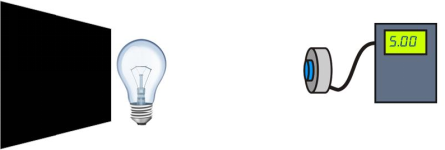

1. Measuring the ambient light level
   1. With the black card still in place, take several readings of the illuminance with the light source on.

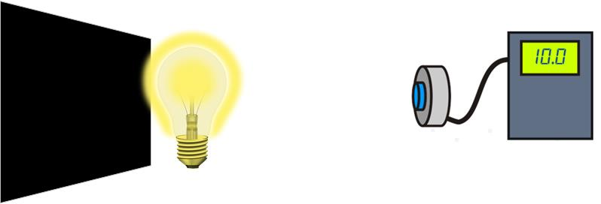

1. Measuring the light source
   1. Subtract the average illuminance value while the light source is off from the average illuminance value while the light source is on. This difference in value represents the amount of light emitted by the light source. Some advanced meters may have this referencing facility built into the device, in which case, the difference can be read directly from the screen.

Do not use the same reference illuminance for all locations – each location requires the reference illuminance to be measured individually.

Record the illuminance difference value for all locations.

1. NOte

Due to the nature of the instrument, it will be sensitive to changes in the ambient light. Whilst the “off” reference reading will help to mitigate most of these issues, some amount of uncertainty remains. This, to some extent, can be reduced by increasing the number of measurement locations around the light source or by fitting the sensor inside a black-coated cylindrical shield. Where practicable, measurements should be taken at night to provide further consistency.

1. Measurement verification

This annex provides two different methods of mounting the sensor around the light in order to obtain consistent results. The first method involves a method of mounting the sensor at some distance away from the light source, but still within the optic. The second method is specifically for use with LED lights.

* 1. Method 1

The first method places the sensing head of the illuminance meter inside a plastic box. This plastic box was also fitted with a laser pointer and power supply. The purpose of the laser pointer is to help with alignment to the light source. A suitable flexible tripod was employed for the mounting of the box within an optic.

The challenges of this method in the field verification of lighthouses include:

* Trying to find a number of measuring location for the tripod, avoiding obstacles mounted around the lamp pedestal;
* Keeping the light measurement box clear of the lamps, should the lamp change operate;
* manoeuvring the tripod and working within the rotating optic;
* Safety of the test operator.

This method has been experimentally validated on the Venture 1000W metal halide lamp at Flamborough Lighthouse and on three 250W tungsten halogen lamps at Whitby Lighthouse.

* 1. Method 2

A metallic tube was created that sits over the upper heatsink of the light, and is sized as such to prevent as little lateral movement as possible. The top of the tube rests on top of the heatsink to provide a stable vertical datum for the sensor. The illuminance sensor is mounted on the side of the tube, directly in front of the LEDs (see Figure 12. The inside of the tube is mostly painted black to reduce the amount of reflections internally, and thus reducing the uncertainty in the measurement.

During the measurement, the LEDs can be tested individually and the tube is rotated until the reading has peaked for that particular LED. The illuminance is then recorded for that LED. The method was experimentally validated at Caldey Lighthouse.

During these trials a number of challenges were still present such as:

* Variation in performance from different measurement location;
* Safety of the test operator.

1. SUMMARY

The methods provide means by which the light output can be measured with consistent results. However, the true effectiveness of the methods will only be determined with subsequent measurements using the techniques. This will take some time to determine, especially for LED light sources that degrade relatively slowly.

Furthermore, validation tests conducted on both old and new lamps at Flamborough Head indicated that, on average, the older lamp has degraded by an amount in line with the manufacturer’s data sheets.

If the measurement process is sufficiently accurate, it should be possible to determine when the lamps should be changed, based on its luminous output, rather than simply based on operational hours. This does already show promise for the technique.

It is, in theory, possible to use the technique for integrated lanterns too. However, due to the narrow vertical divergence, it is likely that much larger repeatable errors will occur since a small variation in height can result in larger variations in illuminance. This aspect needs to be further considered in the future.